TABLE OF CONTENTS

31-235 TILP (Transitional Independent Living Plan) Policy Pages 2-8
and Procedures

Attachment 1 Instructions for creating the TILP in CWS/CMS Pages 1-4

Attachment 2 TILP Form Pages 1-4

- GENERAL

Effectively immediately, counties are to begin using the new TILP (Transitional Independent Living Plan) & Agreement, which contains a one page instruction sheet and a one page core plan/agreement that outlines up to four achievable goals, activities to support the goals, responsible parties for the activities, planned completion dates and indicators of progress toward reaching goals.

The Supportive Transitional Emancipation Program Transitional Housing Program-Plus TILP, STEP 8 (07/02), will continue to be used for participants in those programs, pursuant to MPP 30-918. Additionally, County Probation Officers, who do not have access to CWS/CMS, are required to provide TILP information in the case file and to submit the TILP with the case plan for court hearings. County Probation Officers have the option to continue using the current TILP document.

- DEFINITIONS

Independent Living Skills Program – A federally funded program whose goal is to enable participating youth to successfully make the transition from foster care to independent living by providing services and programs.

TILP - Transitional Independent Living Plan

- REFERENCE

AB 636 Assembly Bill 636 – Child Welfare System Improvement
and Accountability Act
ACL 03-61 CWS/CMS Data Entry
ACL 08-31 New Transitional Independent Living Plan (TILP)
Agreement For Foster Youth
ACL 88-99 Guidelines For The Independent Living Skills Program
ACIN 1-25-91 Independent Living Program Guidelines
DM 31-525 Independent Living Skills Program
Division 31 Section 31-236 Transitional Independent Living Plan (TILP)
MPP 30-918 Manual of Policies and Procedures (Supportive Transition
Emancipation Program-Transitional Housing Program
(STEP-THP) Plus Living Program
MPP 31-236(a) Manual of Policies and Procedures (developing the TILP for
Youth between the ages of 15 ½ and 16)
- POLICY

The new TILP is to be created for Independent Living Program (ILP) eligible youth who are in care, and whose case is in the Child Welfare Services/Case Management System (CWS/CMS). A TILP is to be developed for a youth who is between the ages of 15 ½ and 16 by the county social worker/probation officer, with the active participation of the youth and other supporting adults (caregivers). Based on the collaboration and review of the youth’s functioning level, as identified in the completed assessment, the following information must be documented on the TILP:

►Goals identified by the youth
►Any supportive activities necessary to ensure that the youth reaches his/her goals
►Who is responsible to perform the supportive activities
►A target completion date for achieving the goals
►Progress toward reaching the goals

The TILP is intended to be a clear, easy to follow plan with concrete steps designed to help the youth transition into adulthood. As such, the goals and activities are individualized and must be written in a manner that is clearly stated and easy for the youth to understand the steps needed to make progress toward reaching the goals the youth has identified.

Once the youth has made progress toward reaching his/her goals, it should be indicated on the TILP by checking the appropriate box in the progress column. The TILP covers a six month timeframe. A new TILP must be completed at least once every six months, or more often if needed. Goals that have not been met can be transferred to the new TILP.

If a youth has chosen not to participate in the ILP services that are on the TILP, pursuant to MPP section 31-236 (d), the social worker/probation officer must offer ILP services to the youth at least once every six months. A consistent effort must be made to engage the youth in ILP services. This can be achieved by modifying or revising the goals to align with the youth’s assessed needs.

Even though a youth may decline to participate in ILP services, the social worker
or probation officer must still work with the youth to develop a transition plan
that is inclusive of educational, employment and/or other age and developmentally appropriate life skills goals that will help the youth successfully transition out of foster care.

After the TILP is created, each party signs and receives a copy of the TILP. The handwritten hard copy of the TILP must contain all the necessary signatures. This document should be maintained in the case file. A copy of the signed document will be attached to the case plan for court hearings (the child’s current address should be removed and/or marked confidential).

- PROCEDURE

A. The Social Casework Specialist (Social Worker) will:

- Develop a TILP for every youth who is at least 15 ½ years old or older, and is in out-of-home placement. The TILP should be developed in collaboration between the youth, the Social Worker, the child’s caregiver, and/or other dedicated adult(s) in the youth’s life.

- Create the TILP (blank form) and save as a document through CWS/CMS (see Attachment 1 for specific CWS/CMS instructions).

b. Set an appointment with the caregiver and youth to fill out
the TILP form.

c. Every goal listed in the TILP must contain:

1) supportive activities to help the youth reach the goal
2) who is responsible to perform the supportive activities
3) a target completion date for achieving the goals

- After the TILP is completed the caregiver, youth and Social Worker must sign and date the document. Each party receives a copy. The original signature copy must be maintained in the case file.

- Attach a copy of the signed document to the case plan for
court hearings. Ensure that the child’s current address is removed or listed as confidential on the TILP prior to attaching it to the case plan for court hearings. Must add “signature on file” on the document within CWS/CMS.

- Document any progress on the TILP by checking the
appropriate box in the progress column. Goals that have not
been met can be transferred to the new TILP.

- A new TILP must be completed at least once every six-
months, or more often if needed.

- Refer Youth to ILSP (Independent Living Skills Program) for
ILP Services:

  - Once the TILP has been created, the Social Worker must
maintain the original signature copy in the case file.

  - The TILP is used as the official referral to ILSP. The Social Worker will attach the child’s SOC 158a ( Foster Child’s Data Record and AFDC-FC Certification) form to the TILP prior to forwarding to ILSP.

NOTE: The Social Worker will ensure that the child’s current telephone number is provided at the time of the LSP
Referral.

  - The Social Worker should periodically check CWS/CMS for
any ILP Service activities that ILSP staff have provided on behalf of their youth. The Social Worker may also contact ILSP staff directly to inquire about service activities that have been provided.

  - The Social Worker is responsible for updating the youth’s
TILP, as it relates to any goals associated with the ILP activities provided to the youth.

- When a youth elects not to participate in ILP services that are on the TILP:

  - Offer ILP services to the youth at least once every six-
months.

  - Demonstrate a consistent effort to engage the youth in ILP
services, which should be listed in their contact notes in CWS/CMS.

  - Should attempt to modify or revise the goals in the TILP in
an effort to engage the youth in ILP services

  - Work with the youth to develop a Transition Plan that will
help the youth successfully transition out of foster care. The transition plan must include goals in:

1) education
2) employment and/or
    - other age and developmentally appropriate life skills/goals

- The Social Casework Supervisor will ensure:

  - A TILP is created by their Staff for every youth who is at least 15 ½ years old or older and in collaboration between the Social Worker, the youth, and the child’s caregiver, and/or other dedicated adult(s) in the youth’s life.

- The TILP is created in CWS/CMS and a hardcopy of the signed TILP is maintained in the case file.

- A copy of the signed TILP document is attached to the case plan for court hearings. Ensure that the child’s current address listed on the TILP is kept confidential, either by removing it or marking the address as confidential.

- A new TILP is created at least once every six-months or qualifying youth and more often if needed.

- The Social Workers periodically check CWS/CMS for ILP service activities that were provided by ILSP.

- The Social Workers update the youth’s TILP, as it relates to any
goals associated with the ILP activities provided to the youth.

- A copy of the SOC 158a (Foster Child’s Data Record) is attached to all TILP referrals to the Independent Living Skills Program (ILSP) along with a current contact number for the Youth being referred for services.

- If a youth elects not to participate in ILP services that:

  - The Social Worker offers ILP services to them at least once
every six-months.

  - A Transition Plan is created for the youth that includes
education, employment and/or other age and developmentally appropriate life skills/goals.

  - The Social Worker demonstrates a consistent effort in trying
to engage the youth in ILP services through appropriate documentation in CWS/CMS.

- The Independent Living Skills Program will:

1. Take receipt of the current TILP and SOC 158a from District Social Workers.

- Attempt to engage the youth in ILP services.

- When ILP services are provided to the youth, ensure that information is entered into CWS/CMS in a timely manner.

NOTE: Only ILP services in which a youth has begun participation should be entered into CWS/CMS.

- When necessary, coordinate with the primary Social Worker regarding ILP service activities.

- Ensure that contacts to engage the youth in ILP services are documented in CWS/CMS, including attempted contacts (which should be listed as a regular contact, not an ILP service).

D. The Independent Living Skills Coordinator will ensure:

- When a TILP is received, that efforts are made to engage
the youth in ILS services and that those efforts are entered into
CWS/CMS.

- When ILP services are provided to the youth, those Services are
appropriately entered into CWS/CMS in a timely manner.

3. ILP services are made available to qualifying youth in coordination
with District Staff.

4. If a youth resides in another county, send TILP to refer youth to the local ILSP program.

CONTACT PERSON: First line supervisors and above may contact the ILP Program Analyst with any questions concerning this department manual section.

Quick Guide to Creating a TILP
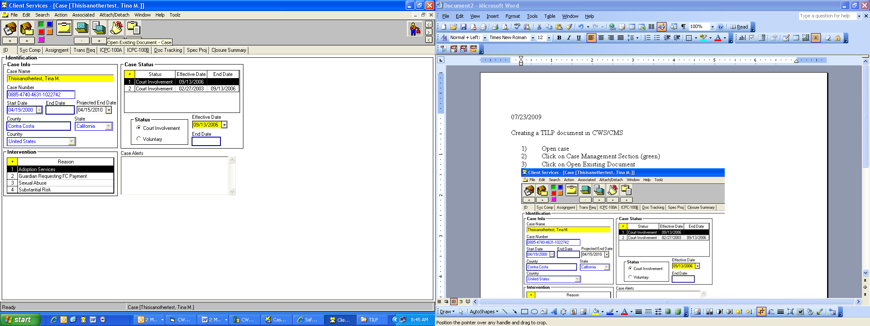 | - Open case  - Click on Case Management Section (green)  - Click on + for Open Existing Document if creating a new TILP

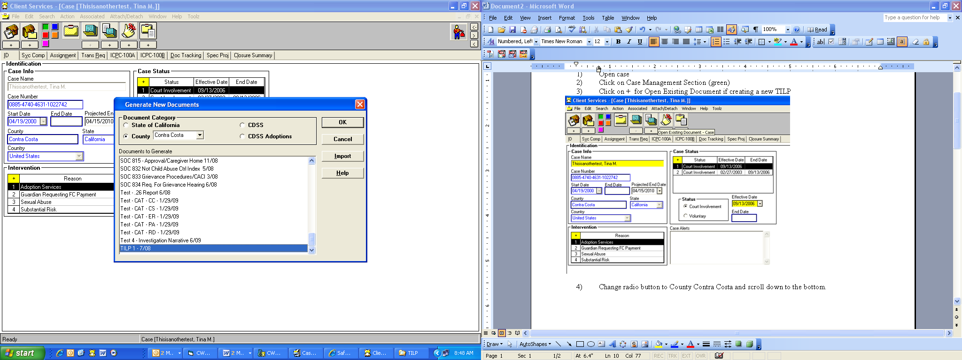  Click on TILP 1– 7/08, then click OK. | - Change radio button to County Contra Costa and scroll down to the bottom.  6) The new TILP document will auto populate in WORD. This document will need to be unprotected in order to work with it.  - To unprotect the document in WORD, click on Tools, then click on Unprotect.

Record on Associated Services page of a Contact the ILP Services for Outcome Measures
Compliance for SafeMeasures
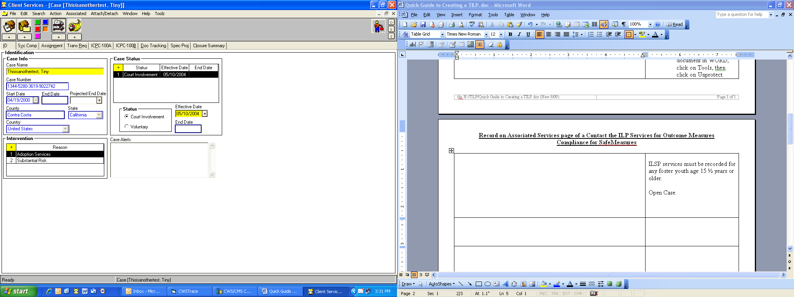 | ILSP services must be recorded for any foster youth age 15 ½ years or older.  - Open Case.  - Click on + to create a new contact.

Record on Associated Services page of a Contact the ILP Services for Outcome Measures
Compliance for SafeMeasures (continued)
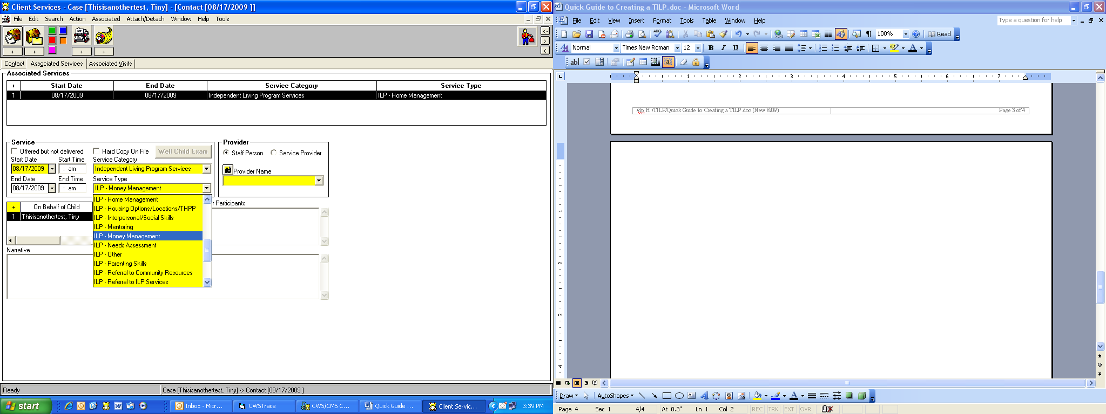 | - Click on Associated Services page/tab.  - Complete all mandatory fields for each ILP services provided to youth. (Note a separate ILP service must be entered for EACH service.)  - Complete the Provider Name as the name of the staff providing the service.  - Click on the + under Associated Services to add another ILP service provided to the youth. There must be a row for each one. Complete all mandatory yellow fields.  - Save to Database.

Transitional Independent Living Plan & Agreement

Youth: ___________________________________ Date of Birth: _____________Age ___Ethnicity________

Address: ____________________________________________________________________________________

Instructions To Youth: The purpose of this agreement is to capture the goals you are agreeing to achieve over the next 6 months. It is a good organizing tool to help you stay focused and keep track of your progress toward accomplishing each goal. Your Social Worker/Probation Officer and caregiver will also have copies of this agreement and will help you achieve your goals.

Instructions to Caregiver: You are agreeing to assist the youth in the development of their ILP goals and to support the youth in completing the activities.

Instructions to Social Worker/Probation Officer: You are agreeing to assist the youth and the caregiver in completing this form, and develop Planned Services that will assist the youth in meeting his/her goals. Document the Planned Services and Delivered Services in CWS/CMS. Probation officers: use manual documentation procedures.

Service goals and activities to be addressed in the plan:
Goals are individualized based on your assessment and may include examples such as:

- develop a life-long connection to a supportive adult
- graduate from high school
- obtain a part-time job
- invest savings from part-time job
- develop community connections
- obtain a scholarship to attend college
- develop competency in the life skill of ___________________________________

Activities are individualized to help meet a specific goal. Example – if high school graduation is a goal, the youth directed activity might be to attend classes regularly with no tardies for the next 6 months.
For youth participating in ILP services, activities are reportable as ILP Delivered Services in CMS. The social worker shall select from one or more of the following ILP Service Types that an individualized completed activity fits in:

- Received ILP Needs Assessment • ILP Room and Board Financial Assistance
- ILP Mentoring • ILP Transitional Housing, THP, THP Plus
- ILP Education • ILP Home Management
- ILP Education Post Secondary • ILP Time Management
- ILP Education Financial Assistance • ILP Parenting Skills
- ILP Career/Job Guidance • ILP Interpersonal/Social Skills
- ILP Employment/Vocational Training • ILP Financial Assistance
- ILP Money Management • ILP Transportation
- ILP Consumer Skills • ILP (Stipends/Incentives)
- ILP Health Care • Other

  - I understand that if I am employed as part of this plan, my earned income will be disregarded, as the purpose of my employment is to gain knowledge of needed work skills, habits and responsibilities to maintain employment. (WIC 11008.15)

  - I understand that I can retain cash savings up to $10,000 under this plan in an insured savings account and any withdrawal requires the written approval of my social worker/probation officer and must be used for purposes directly related to my transitional goals. (WIC 11155.5)

  - I understand that I will receive assistance to obtain my personal documents and information about financial aid for postsecondary education/training. (WIC 16001.9)

Transitional Independent Living Plan & Agreement

Youth: ____________________________________________ DOB: _________ Age:______ Ethnicity:______________

Case Worker Name:___________________________ Case Worker phone:_____________________

TILP 6-month timeline: __________to _________.
Date Independent Living Needs Assessment completed: ___________

If I have not participated in the ILP program before, I agree to participate now.
Based on the assessment of my level of functioning, the following transitional goals and activities meet my
current needs.

Goal | Activity | Responsible Parties | Planned  Completion Date | Progress Date
Goal #1: |  |  |  | Met Goal  Date ________  Satisfactory Progress  Needs more time/assistance.  Goal needs modification.
Goal #2: |  |  |  | Met Goal  Date ________  Satisfactory Progress  Needs more time/assistance.  Goal needs modification.
Goal # 3: |  |  |  | Met Goal  Date ________  Satisfactory Progress  Needs more time/assistance.  Goal needs modification.
Goal #4: |  |  |  | Met Goal  Date ________  Satisfactory Progress  Needs more time/assistance.  Goal needs modification.

This Agreement will be updated on: _______________________ Update # __________

Signing this agreement means we will all work to complete the steps necessary to help the youth reach his/her goals.

____________________________________________________ ______________________
Youth’s signature Date

____________________________________________________ ______________________

Caregiver’s signature Date

____________________________________________________ _______________________

Social Worker/Probation Officer’s signature Date

