I. PHILOSOPHY

It is of primary importance to enable youth to achieve self-sufficiency prior to leaving the foster care support system. Children and Family Services recognizes the needs of these youth for independent living skill training in order to prepare them to live on their own after leaving foster care.

II. GENERAL/BACKGROUND

- The Independent Living Skills (ILS) Program is a federally funded program whose goal is to enable participating youth to successfully make the transition from foster care to independent living by providing services and programs, following the development of a written Transitional Independent Living Plan (TILP) for each youth.

- Contra Costa County’s ILSP Program includes the following core services:

  - Life Skills Classes
  - Career Counseling and Workshops
  - Personal Development Classes
  - Cooking Classes
  - Employability Training
  - Computer Learning
  - Vocational Training Assistance and Referrals
  - Individual “Living Skills Assessment”
  - Scholarships for colleges and/or job training programs
  - Annual youth retreats/outings
  - Annual Recognition Banquet
  - Monetary incentives for youth participation
  - Counseling and referrals to alternatives to a high school diploma (GED; High School Proficiency)

- Independent Living Skills Programs exist in every county in California and every state. For further information about or to contact Contra Costa County Independent Living Skills Program go to www.cocoilsp.org or call toll free 1-866-994-ILSP (4577).

III. REFERENCE

- Welfare & Institutions Code Section 10600-10619
- Welfare & Institutions Code 16501(c)
- Welfare & Institutions Code 10609.3(e)(1)
- Welfare & Institution Code 366.3(e)(8)
- California Department of Social Services (CDSS) Manual of Policies and Procedures (MPP), Division 31 Section 31-525
- CDSS All County Letter (ACL) #11-09, Senate Bill 654 Independent Living Program (ILP) for Non-Related Guardianships
- Public Law 106-169
- Social Security Act 477
- CDSS MPP Division 31-236
- Federal Code of Regulations, Title 45, Part 1200, Sec. 1355.20
- MPP 30-342.5, Placement Case Management
- EAS 45-201
- ACIN I-25-91, ILS Guidelines
- Admin Bulletin 30-400/2 Income and Savings Disregard
- Contra Costa County Children & Family Services Handbook, Transitional Independent Living Plan Agreement (TILP) for Foster Youth (Section 32-235)
- Contra Costa County Children & Family Services Handbook, Youth Transition Meetings (Section 31-205)

IV. ELIGIBILITY

A. Age

- ILS services are available to youth age 16 and older who are in foster care.

- Wards of guardians and probation youth (with placement orders) age 16 and older are eligible.

- KinGAP, Non-Related Legal Guardianship after 8 years old, or Court dependent at or after age 16.

- Youth receiving Adoption Assistance Program (AAP) funding are eligible if adopted at or after age 16.

- ILS services extend to age 21 for those eligible.

- Youth who are not eligible include youth under probate legal guardianships and/or youth who have only received voluntary services (in home or out of home placement).

Refer to ATTACHMENT I for the Independent Living Skills Program Eligibility Grid.

- After Care Services

- All services listed in General/Background Section B, above are available to those who were in foster care but discontinued receiving foster care on or after the youth becomes 16 years old. A youth may receive After Care Services until he or she is 21 years old.

- Some examples of these situations might be:

  - Youth who leave foster care to live independently.

  - Youth who are no longer in foster care because they have been reunited with their families after the age of 16, and are receiving Family Maintenance program services.

  - Youth whose court-ordered dependency has been terminated and the child welfare case has been closed.

- Out-of-County Placements

1. Eligible dependents of Contra Costa County who are placed out-of-county.

- The County with jurisdiction remains financially responsible for incentives (not to exceed $50 a month), scholarships or any other services for which the youth is eligible.

- The Social Casework Specialist (Social Worker) of record will send the most current Transitional Independent Living Plan (TILP) with demographic information to the ILS Program (SOC 158A).

- Upon receipt of the TILP and the SOC 158A, the Contra Costa County ILS Program completes an out of county referral and forwards it to the ILS Coordinator in the other county.

- The receiving ILS Program is responsible for contacting the youth to discuss participation in the ILS Program.

- There are no guarantees the youth will participate in the other county. However, the out of county ILS Program will report progress to the Contra Costa County ILS Program, who will inform the assigned Social Casework Specialist (Social Worker) of any ILS Program participation by the youth via the CFS ILP 3 Form (found on Form STAR and included in ATTACHMENT II). ILS Program Staff will input the information from the CFS ILP 3 into CWS/CMS for the assigned Social Worker to pull from the Delivered Services Log when printing contacts.

- It is suggested that the youth contact the ILS Program in the other county to inquire about ILS Program services.

- Out-of State Placement

When dependents who are eligible for ILS Program services in this county are placed out-of-state, the assigned Social Casework Specialist (Social Worker) will request the receiving State to provide ILS services. This request should be stated in the cover letter which is sent with the Interstate Compact for Placement of Children (ICPC) packet.

V. TRANSITIONAL INDEPENDENT LIVING PLAN (TILP)

- The assigned Social Casework Specialist (Social Worker) or Social Casework Assistant will complete, with the youth and caregiver the Transitional Independent Living Plan (form TILP 1) for each youth in placement age 15 ½, no later than 16 years old. While completing the TILP, goals and activities to complete those goals will be identified, along with who will be responsible for assisting the youth in completing those goals. A date for goal completion must also be set. The youth, caregiver and social worker must sign the TILP. Refer to the policy for Transitional Independent Living Plan Agreement (TILP) for Foster Youth (Section 31-235) on STARS.

1. One copy of the TILP goes to the youth.

- One copy of the TILP goes to the ILS Program (which must include the actual signature), along with a copy of the most recent SOC 158A.

- One copy to the physical case record.

- Information for completing the TILP and TILP goals should be gathered collaboratively with the youth and caregiver to reflect the following ILP Services Categories (see ATTACHMENT 2 for ILP Service Category Definitions, Form CFS ILP 3, available on FormSTAR).

1. ILP Needs Assessment
2. ILP Mentoring
3. ILP Education
4. ILP Education Post-Secondary
5. ILP Education Financial Assistance
6. ILP Career/Job Guidance
7. ILP Employment/Vocational Training
8. ILP Money Management
9. ILP Consumer Skills
10. ILP Health Care
11. ILP Room and Board Financial Assistance
12. ILP Transitional Housing
13. ILP Home Management
14. ILP Parenting Skills
15. ILP Interpersonal/Social Skills
16. ILP Financial Assistance Other
17. ILP Transportation
18. ILP Housing Options/Locations/THPP
19. ILP Other – Issuing of stipends or incentives

- If the youth is eligible for the ILS Program, but services are not appropriate, the assigned Social Casework Specialist (Social Worker) or Social Casework Assistant must document on the TILP 1 why ILP Services are not appropriate, and forward a copy to ILSP along with the most recent SOC 158A. Services are considered inappropriate only if the youth is physically or mentally not able to benefit from such services, or refuses to participate. Examples would be a youth that is non-ambulatory or non-communicative, a youth that is AWOL or a youth who declines to participate. Social Casework Specialists must document in the case plan reasons why ILP services are not appropriate for the youth.

- ILSP is a voluntary program. For a youth who is not able or chooses not to participate, Independent Living Skills should be provided by the youth’s caregiver and documented on the CFS ILP 3, and given to the assigned Social Casework Specialist on a monthly basis or to the Social Casework Assistant when youth is visited. Information from the CFS ILP 3 can be documented in the contact note in CWS/CMS.

- A TILP will be reviewed and updated every 6 months between the assigned Social Casework Specialist (Social Worker) or Social Casework Assistant, the youth and the caregiver, regardless of youth’s participation in ILSP services.

VI. PROCEDURES AND BEST PRACTICES

A. The assigned Social Work Supervisor II will:

- Be sure that the Social Casework Specialist (Social Worker) and Social Casework Assistant have timely completion of the TILP 1 with eligible youth, along with reviewing and updating the TILPs regularly with the youth.

- Ensure the Social Casework Specialist (Social Worker) and Social Casework Assistant refer the youth to ILSP timely.

- Have the Social Casework Specialist (Social Worker) hold Youth Transition Meetings (YTM) to be sure the youth has an individualized permanency and transition plan (Refer to Youth Transition Meetings Policy, Section 31-205).

B. The assigned Eligibility Work Supervisor I will ensure the Eligibility Worker is forwarding the FC 899 – Speed Letter for youth who are part of Kin-GAP to ILSP.

C. The assigned Social Casework Specialist (Social Worker) or Social Casework Assistant will:

- Upon the youth reaching 15 ½, and/or by the age of 16, refer the youth by forwarding the most recent Transitional Independent Living Plan (TILP 1) and most recent SOC 158A to the ILS Program. Update the youth’s change in address with ILSP by sending the updated SOC 158A.

- For a youth who cannot or chooses not to participate, the assigned Social Casework Specialist or Social Casework Assistant will provide the youth’s caregiver with a copy of the CFS ILP 3 form, where the youth’s ILS efforts will be documented by the youth and the caregiver. The Social Casework Specialist or Social Casework Assistant can then document these ILS Services within the youth’s contact in CWS/CMS.

- Send request for payment of service related to specific TILP goals to ILSP for processing and approval.

- Social Casework Specialists are reminded to use the Youth Transition Meetings (YTM). YTMs can assist in getting a youth engaged further in ILSP, help identify ILSP services and resources, and ensure that the goals set forth in a youth’s TILP are being met, prior to emancipation from foster care. (Refer to Youth Transition Meetings Policy, Section 31-205)

- Social Casework Specialists and Social Casework Assistants are encouraged to use the attached ILSP Booklet (ATTACHMENT 3) that further describes the program in youth friendly language, and may be given to the youth and caregiver to review and for contacting ILSP when needed.

D. The assigned Eligibility Worker will:

- Forward to ILSP the FC 899 - Speed Letter (AKA: ILSP Kin-GAP Referral) for eligible Kin-GAP youth on the youth’s 16th birthday. The FC 899 can be found on FormSTAR.

E. The ILS Program will:

  - Receive the TILP from the assigned Social Casework Specialist or Social Casework Assistant and receive the FC 899 – Speed Letter from Eligibility Workers for Kin-GAP youth, contact and provide outreach to the youth, explain the program, and add the youth’s name to the ILS Program database.

  - Any delivered services will be entered into CWS/CMS as a contact.

  - Consult with assigned Social Casework Specialists or Social Casework Assistants who need to locate ILS related resources.

  - Receive requests for payment of services from Social Casework Specialists and Social Casework Assistants for processing. The expenditures must be related to the specific goal of independent living, as identified on the TILP. These expenditures may include:

    - High school completion incentive (high school diploma, GED or certificate of completion)
    - Higher education incentives
    - Uniforms, school supplies, tools, books (when work related)
    - Transportation to work or job training (term limited)
    - ILS Program specific services related to college
    - Incentive payments for class attendance, successful completion of programs, etc.

VII. INCOME AND SAVINGS DISREGARD

  - Income and incentive payments earned by a youth are exempt, without limit, as income purposes of eligibility and grant determination when received as part of documented participation in the ILS Program and Transitional Independent Living Plan (TILP).

  - Incentive payments earned must be as a direct result of the youth’s participation in ILS Program activities.

  - Eligibility Workers apply savings disregard to savings which exceed the $10,000 limit. This is documented in the TILP.

  - Cash savings, including interest earned shall be deposited by the youth in an account opened by the youth or someone on his/her behalf at a bank or savings and loan institution whose deposits are insured by the Federal Deposit Insurance Corporation (FDIC). This account must be kept separate from other accounts and from other types of sources of cash savings.

  - The case record will include any written authorization by the Social Worker for withdrawal of cash savings for purposes of emancipation, acquired through participation in ILS Program.

VIII. DISCONTINUATION OF ILSP SERVICES

ILS Program services may be provided up to the age of 21 for eligible youth. If an out-of-county youth placed in Contra Costa County returns to their home county or is placed in another county, ILS Program services in Contra Costa County will be discontinued.

IX. ATTACHMENTS

- Attachment I: Independent Living Skills Program Eligibility Grid
- Attachment II: CFS ILS 3, Independent Living Program (ILP) Delivered In-Care and Aftercare Services Report for Youth in County or from another County/State and Definitions of the ILP Service Categories
- Attachment III: ILSP Booklet

CONTACT PERSON: First line Supervisors and above may contact the Program Analyst with
any questions regarding this Department Manual Section.

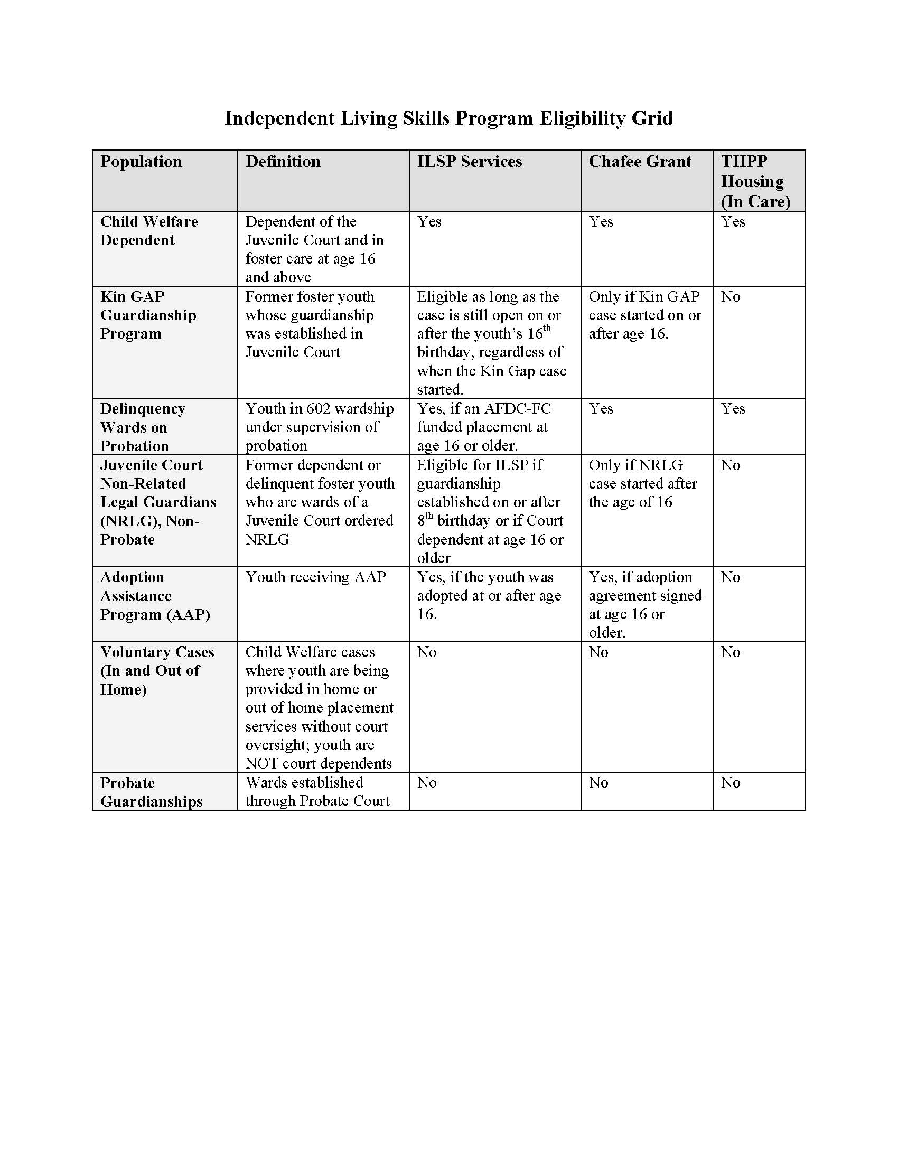
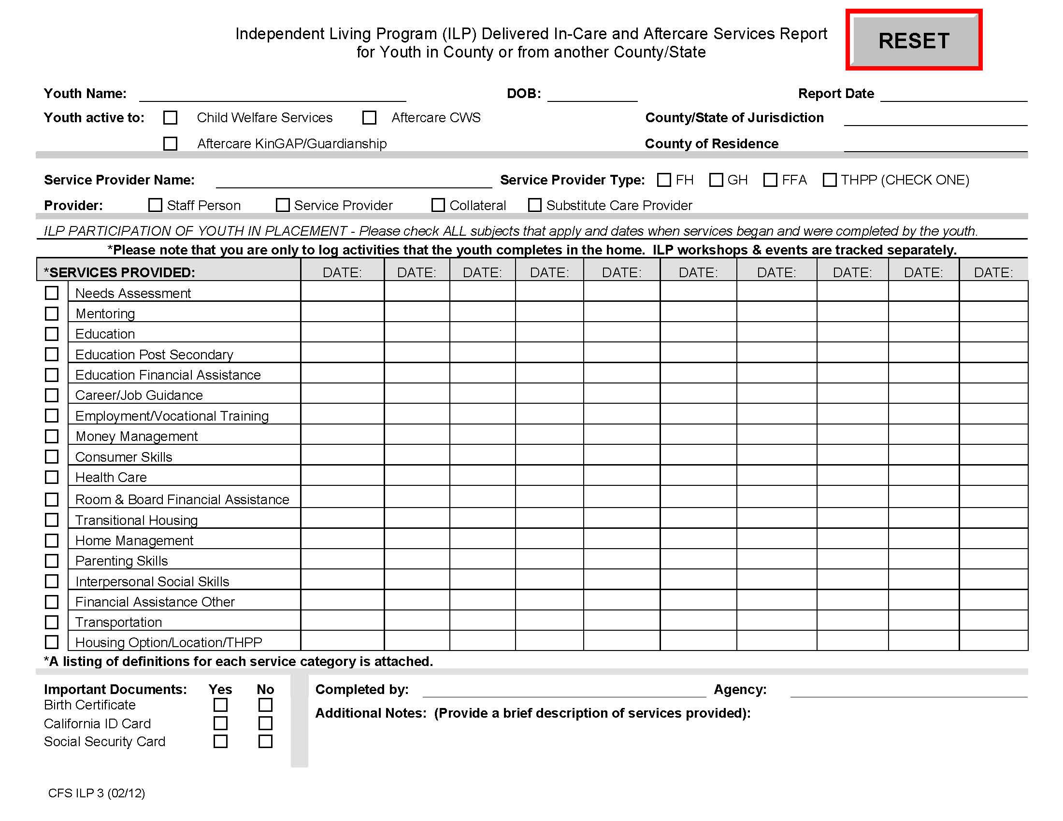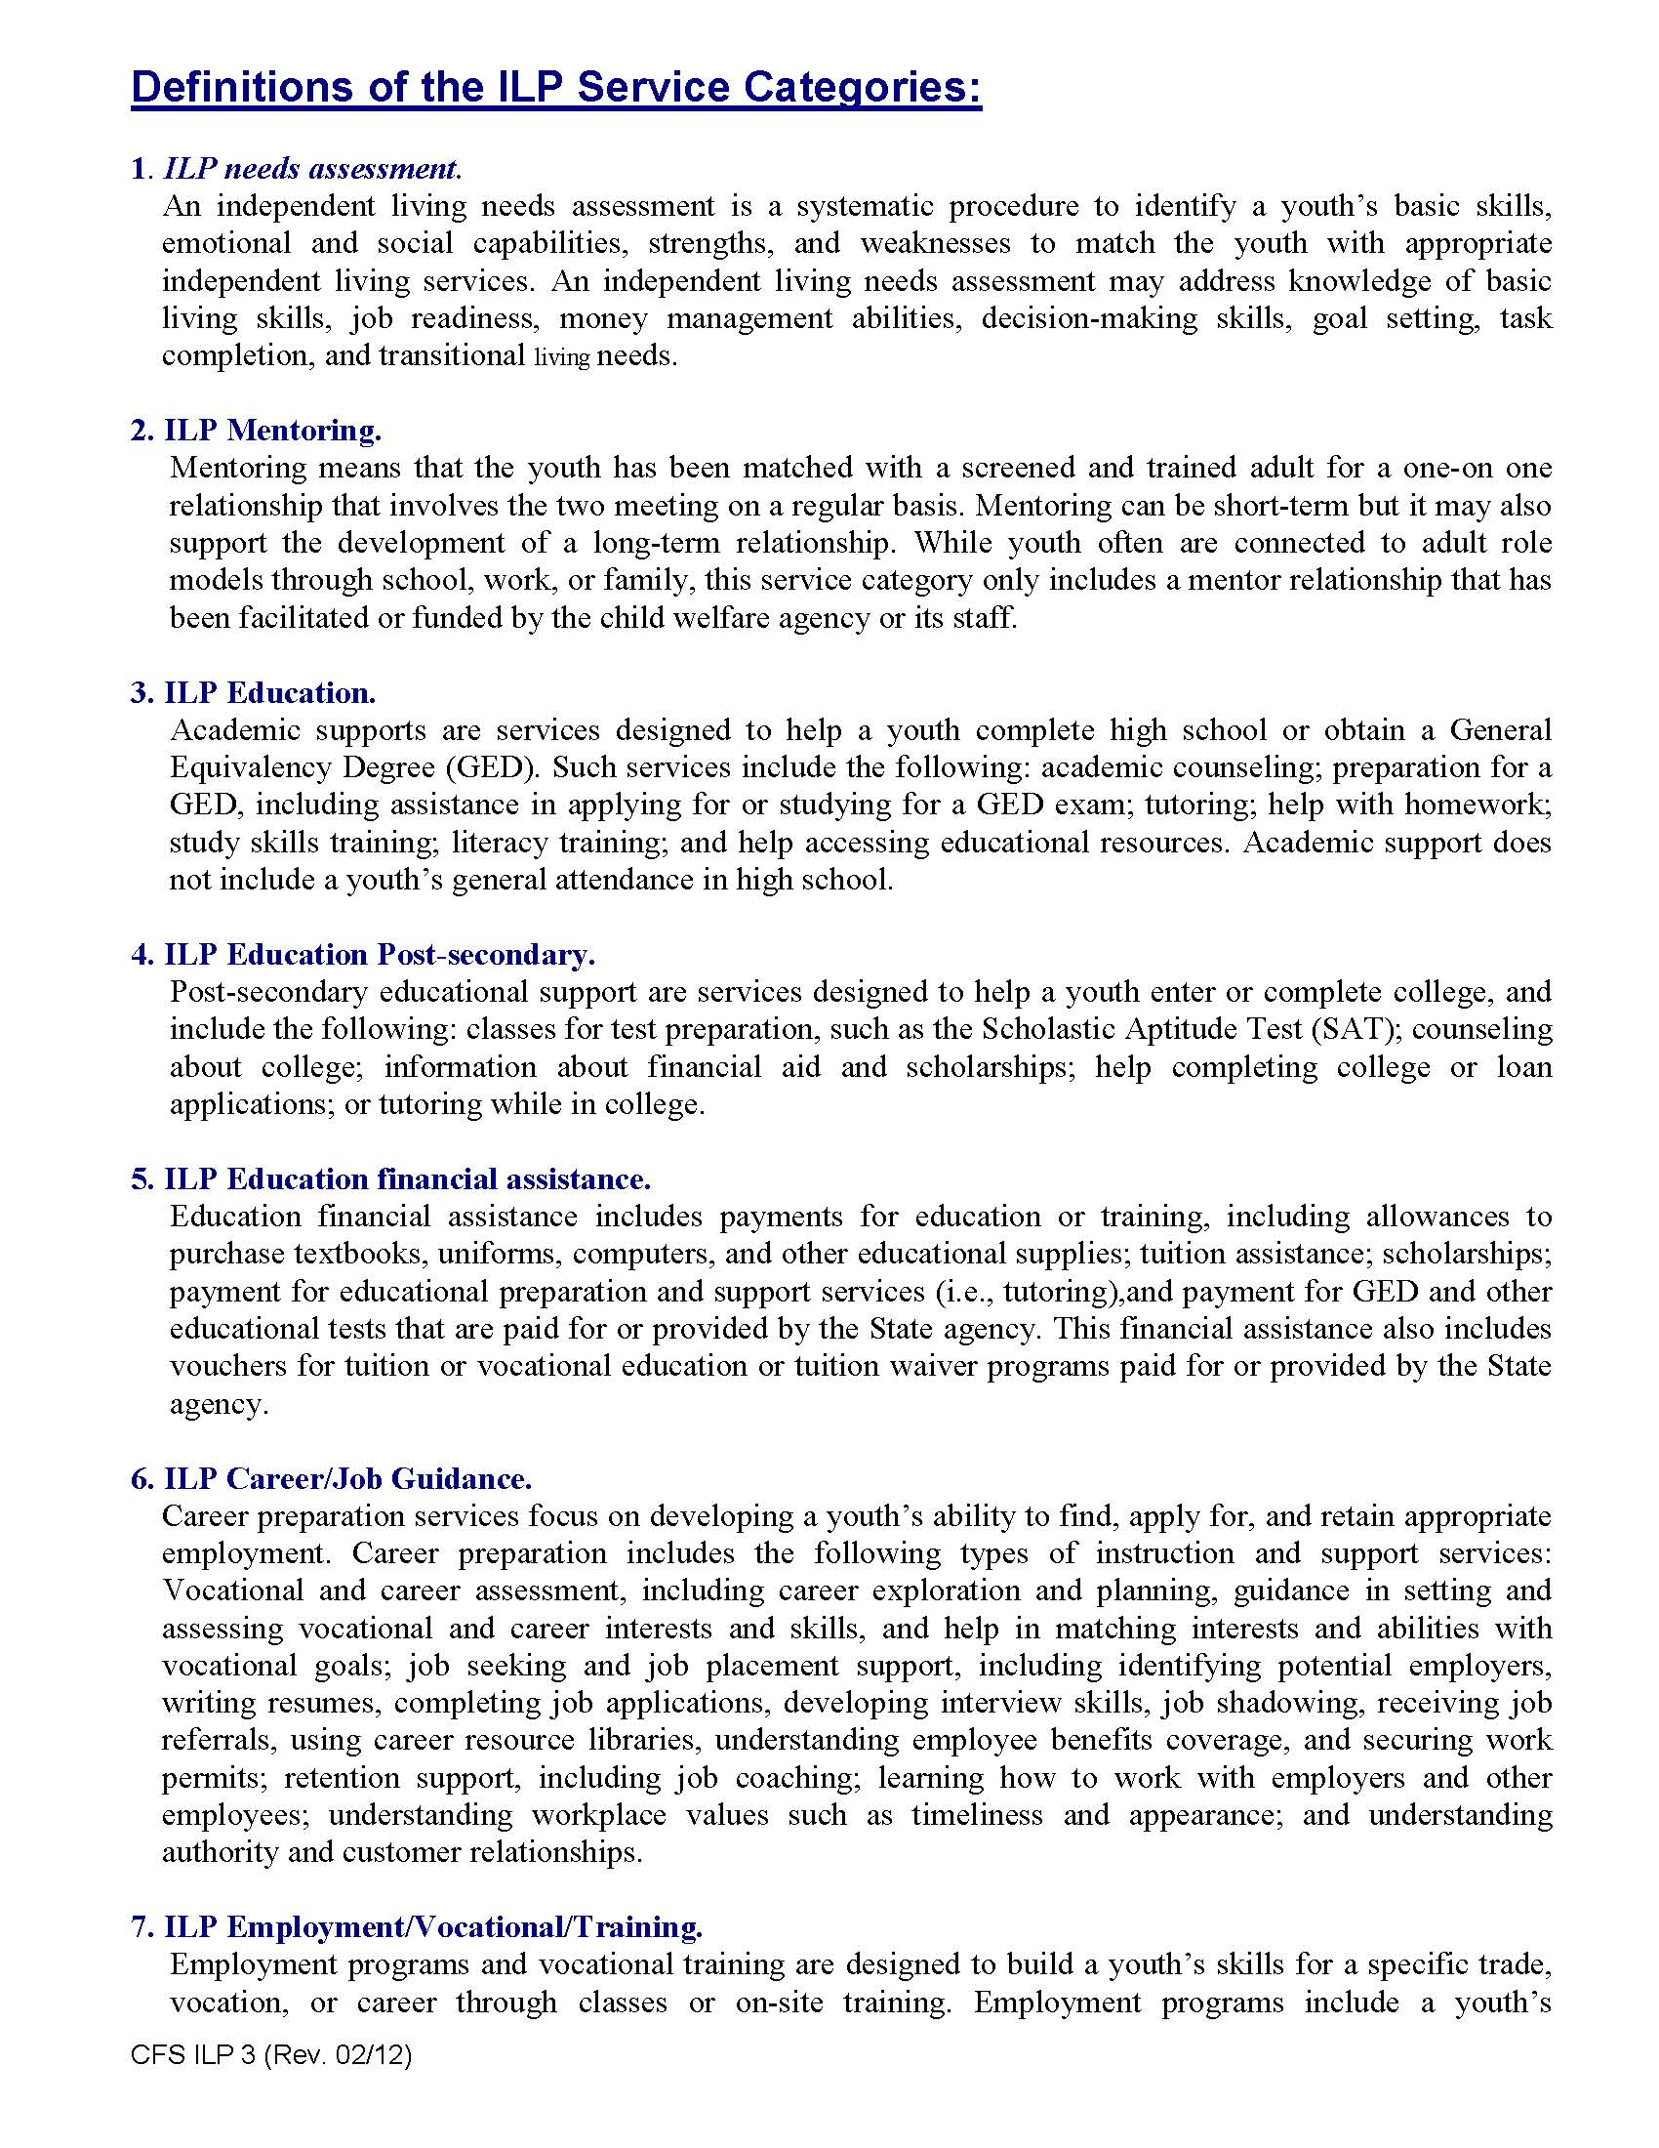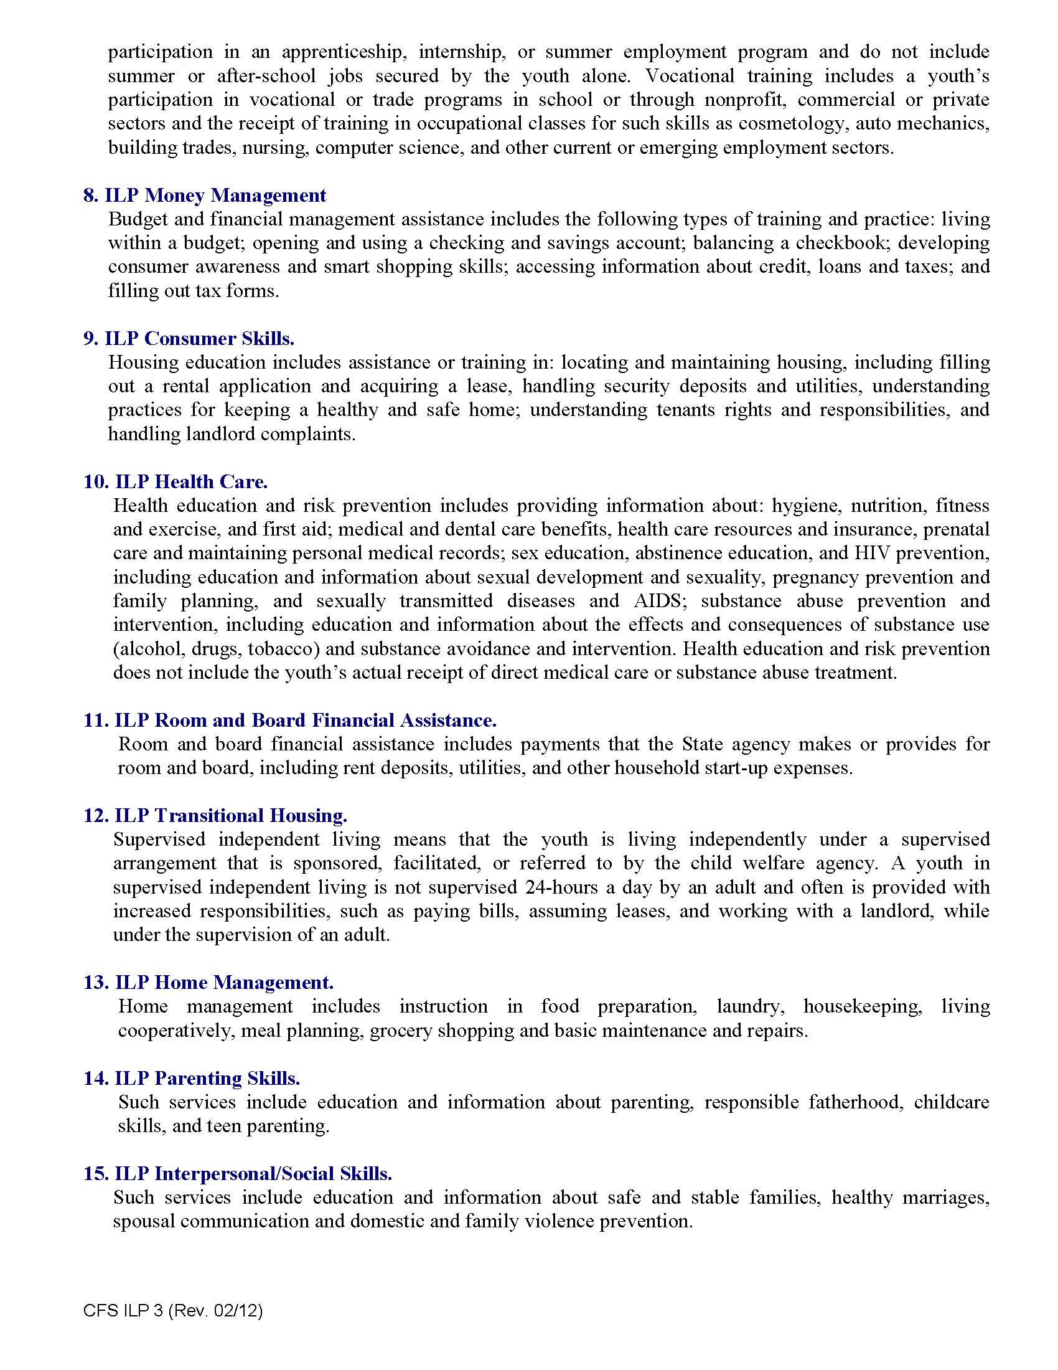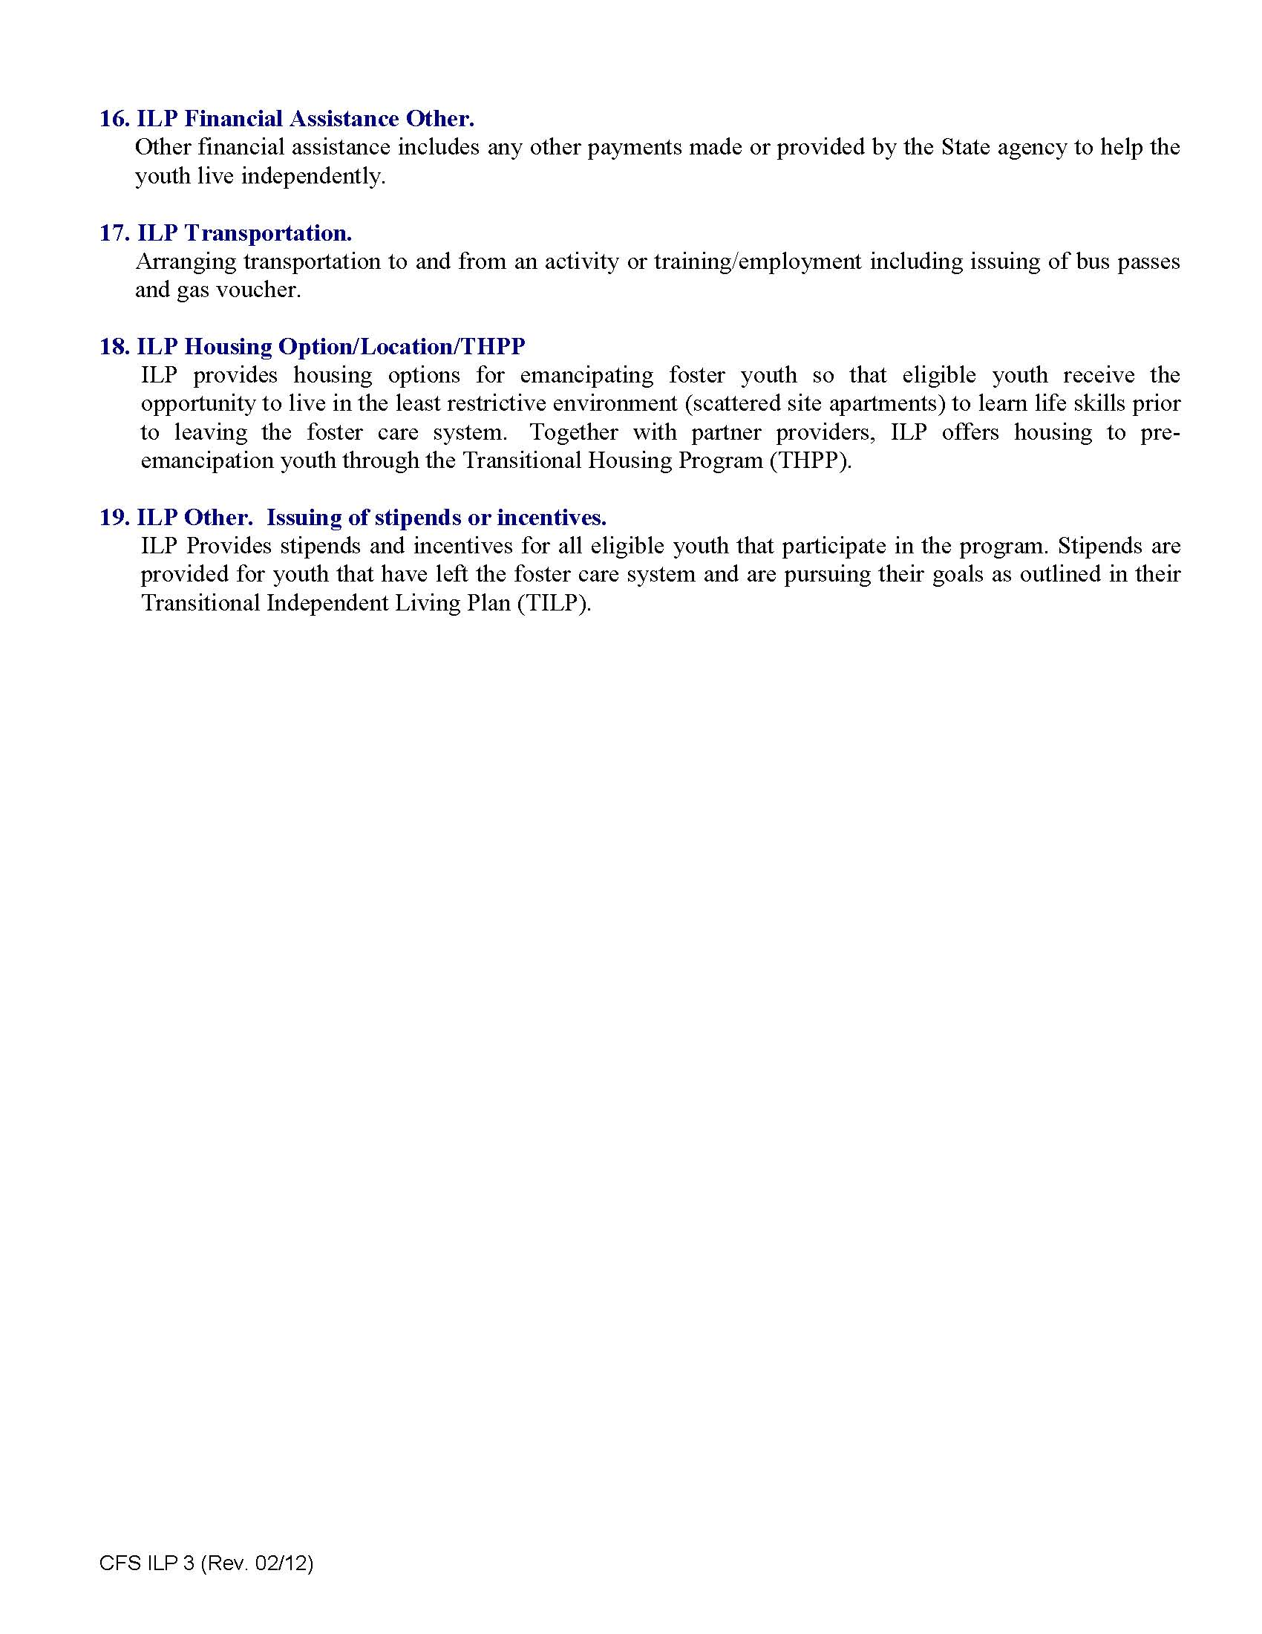
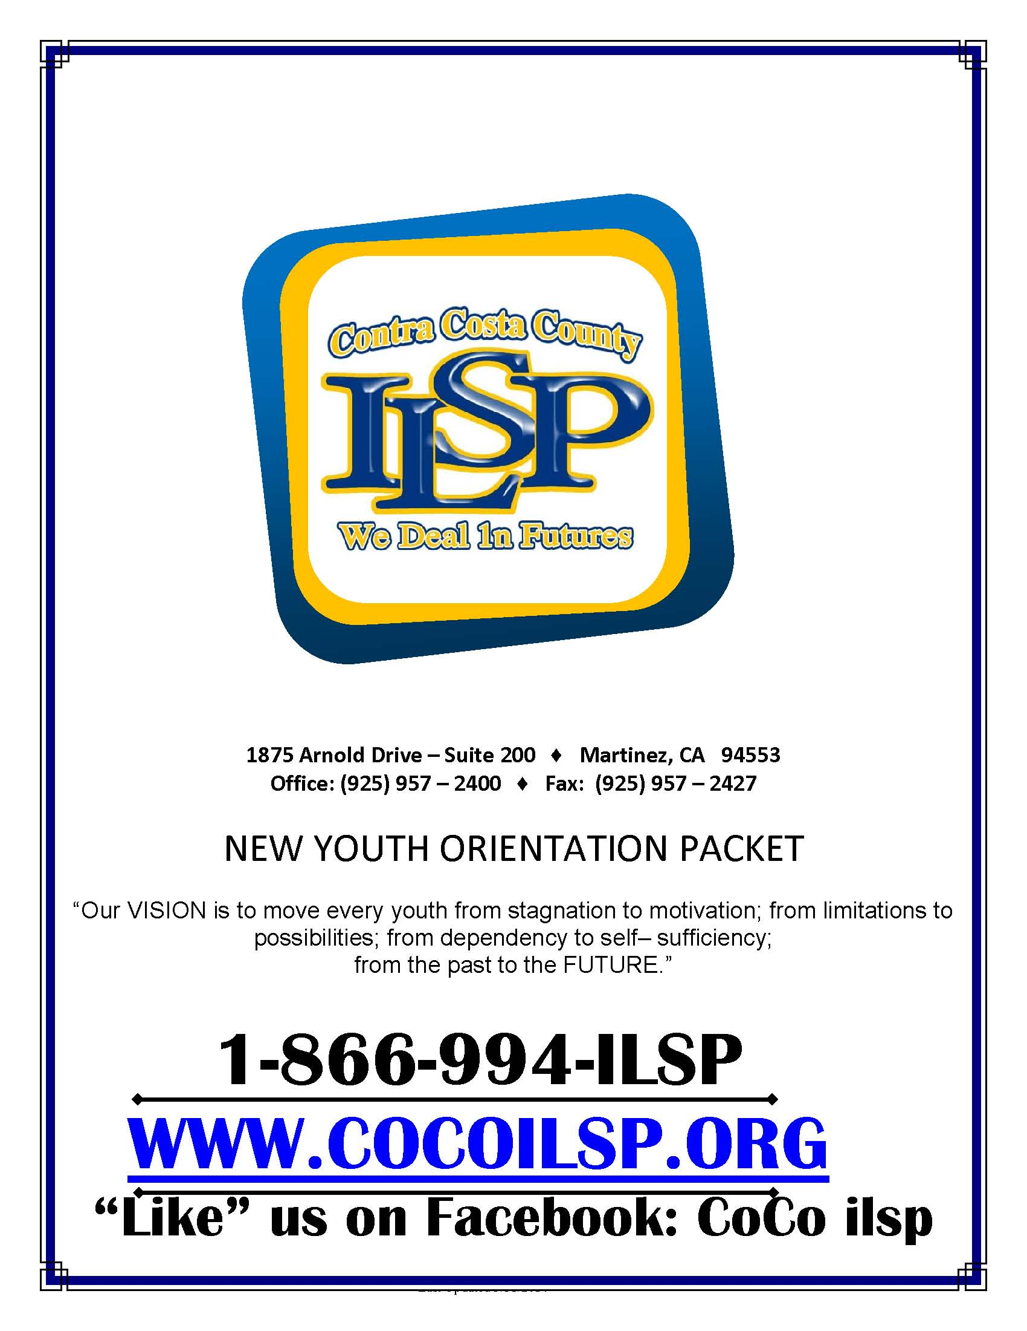

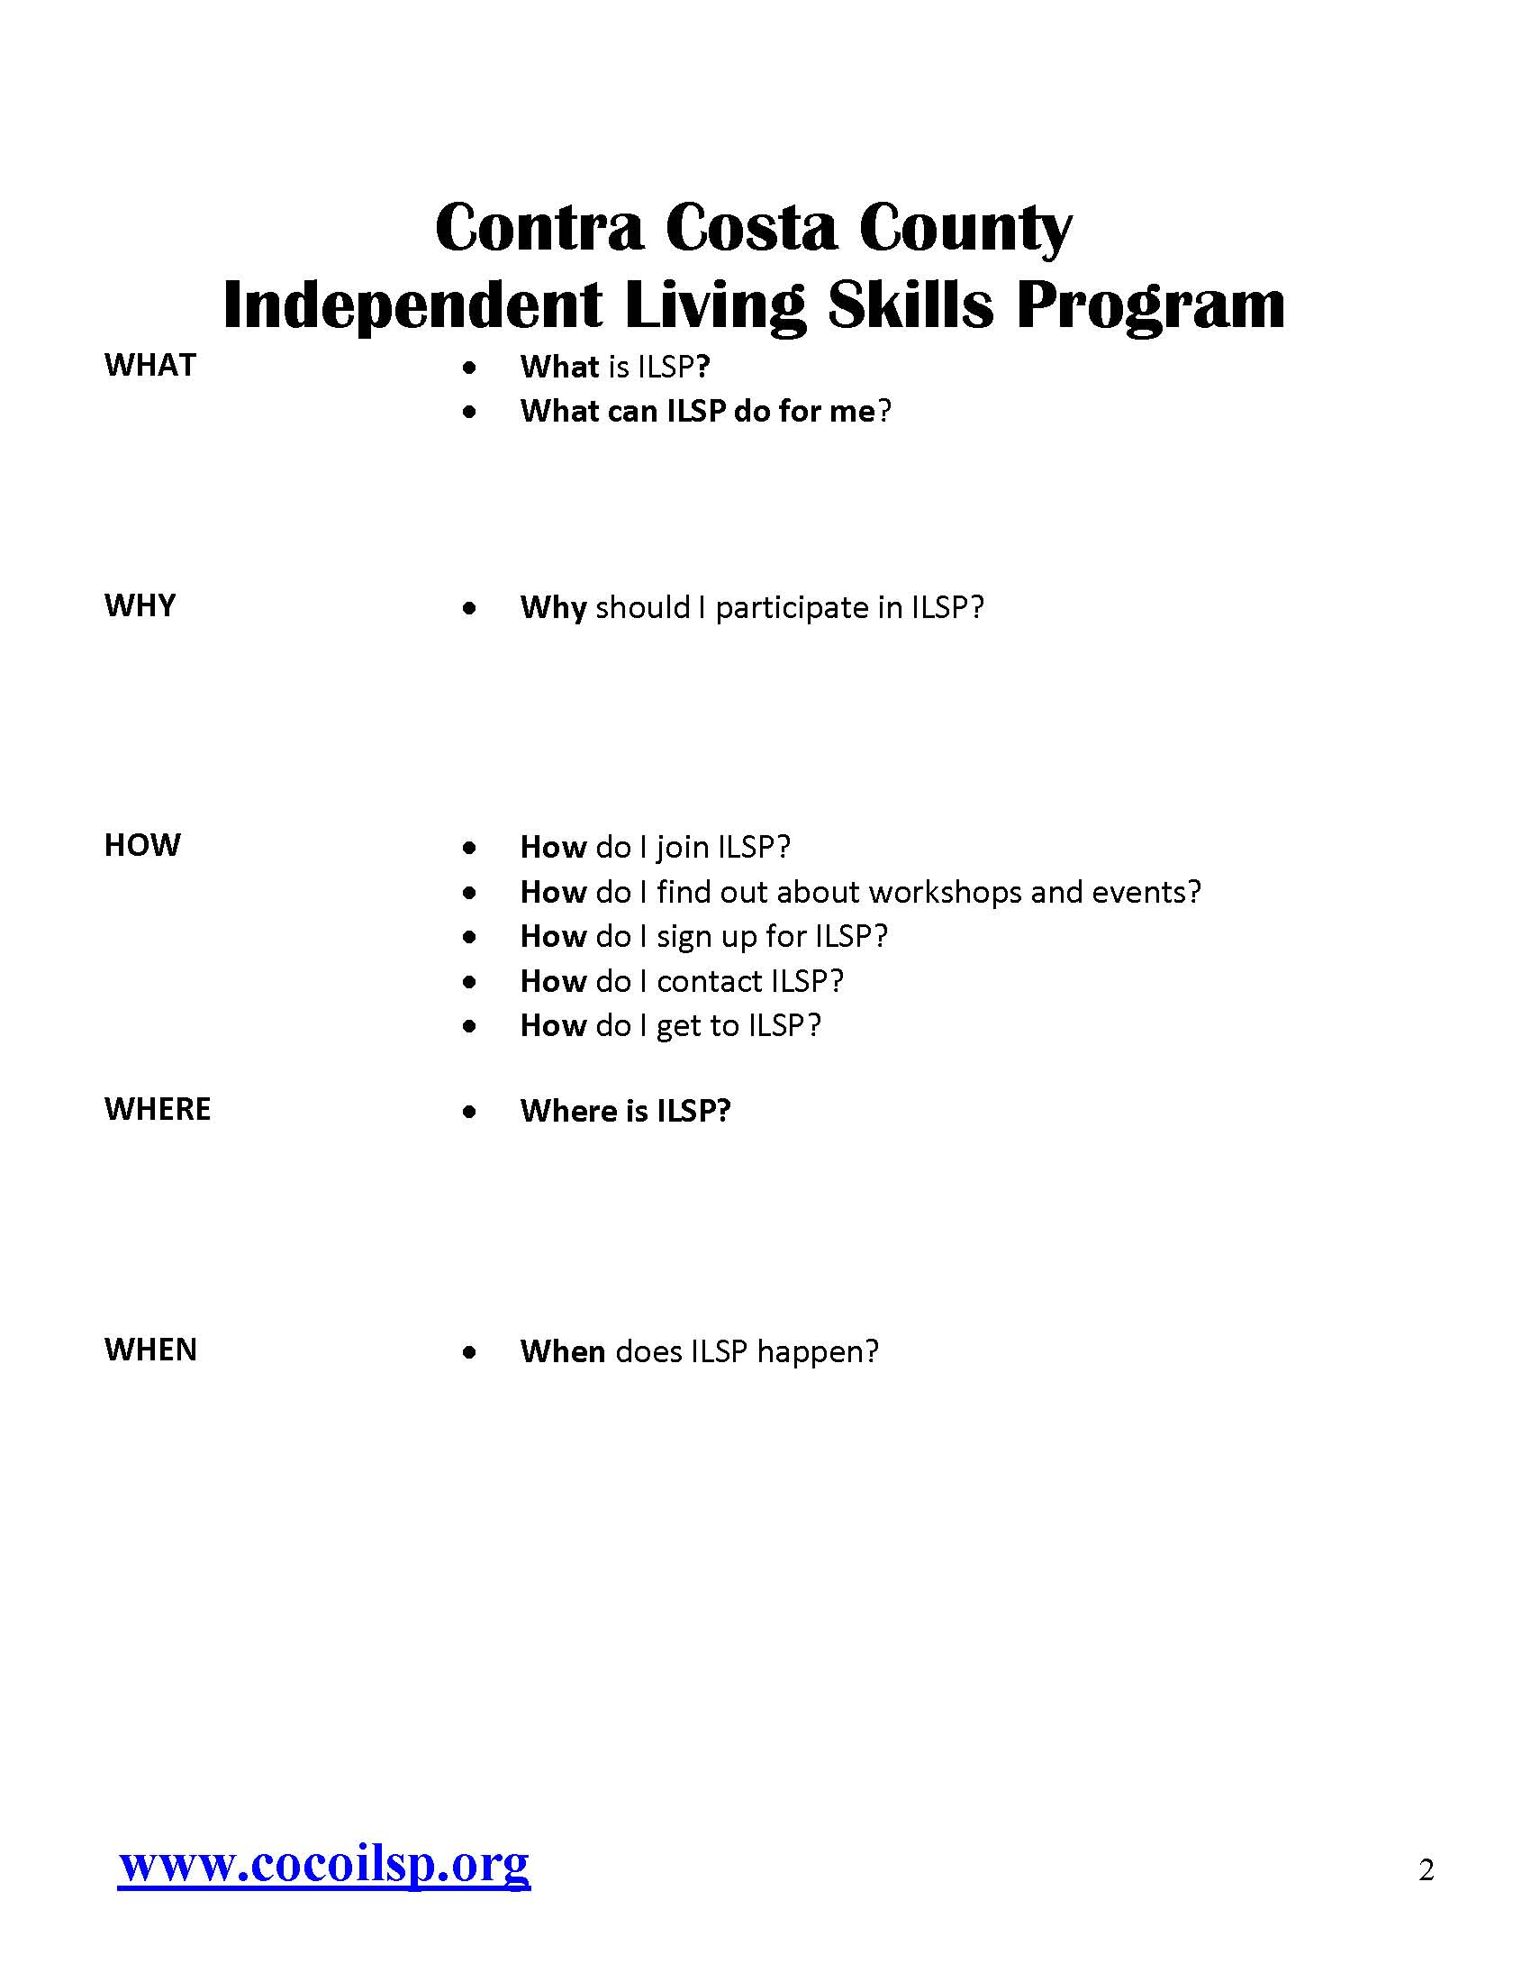
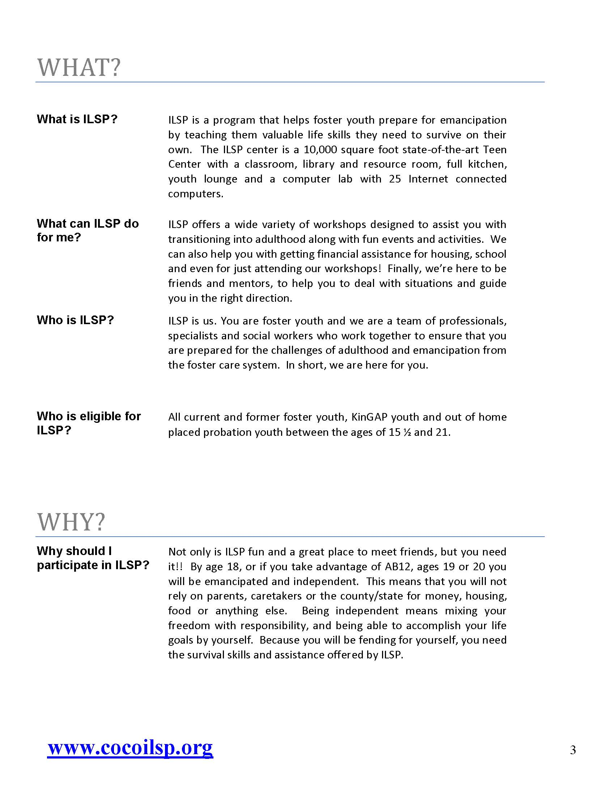
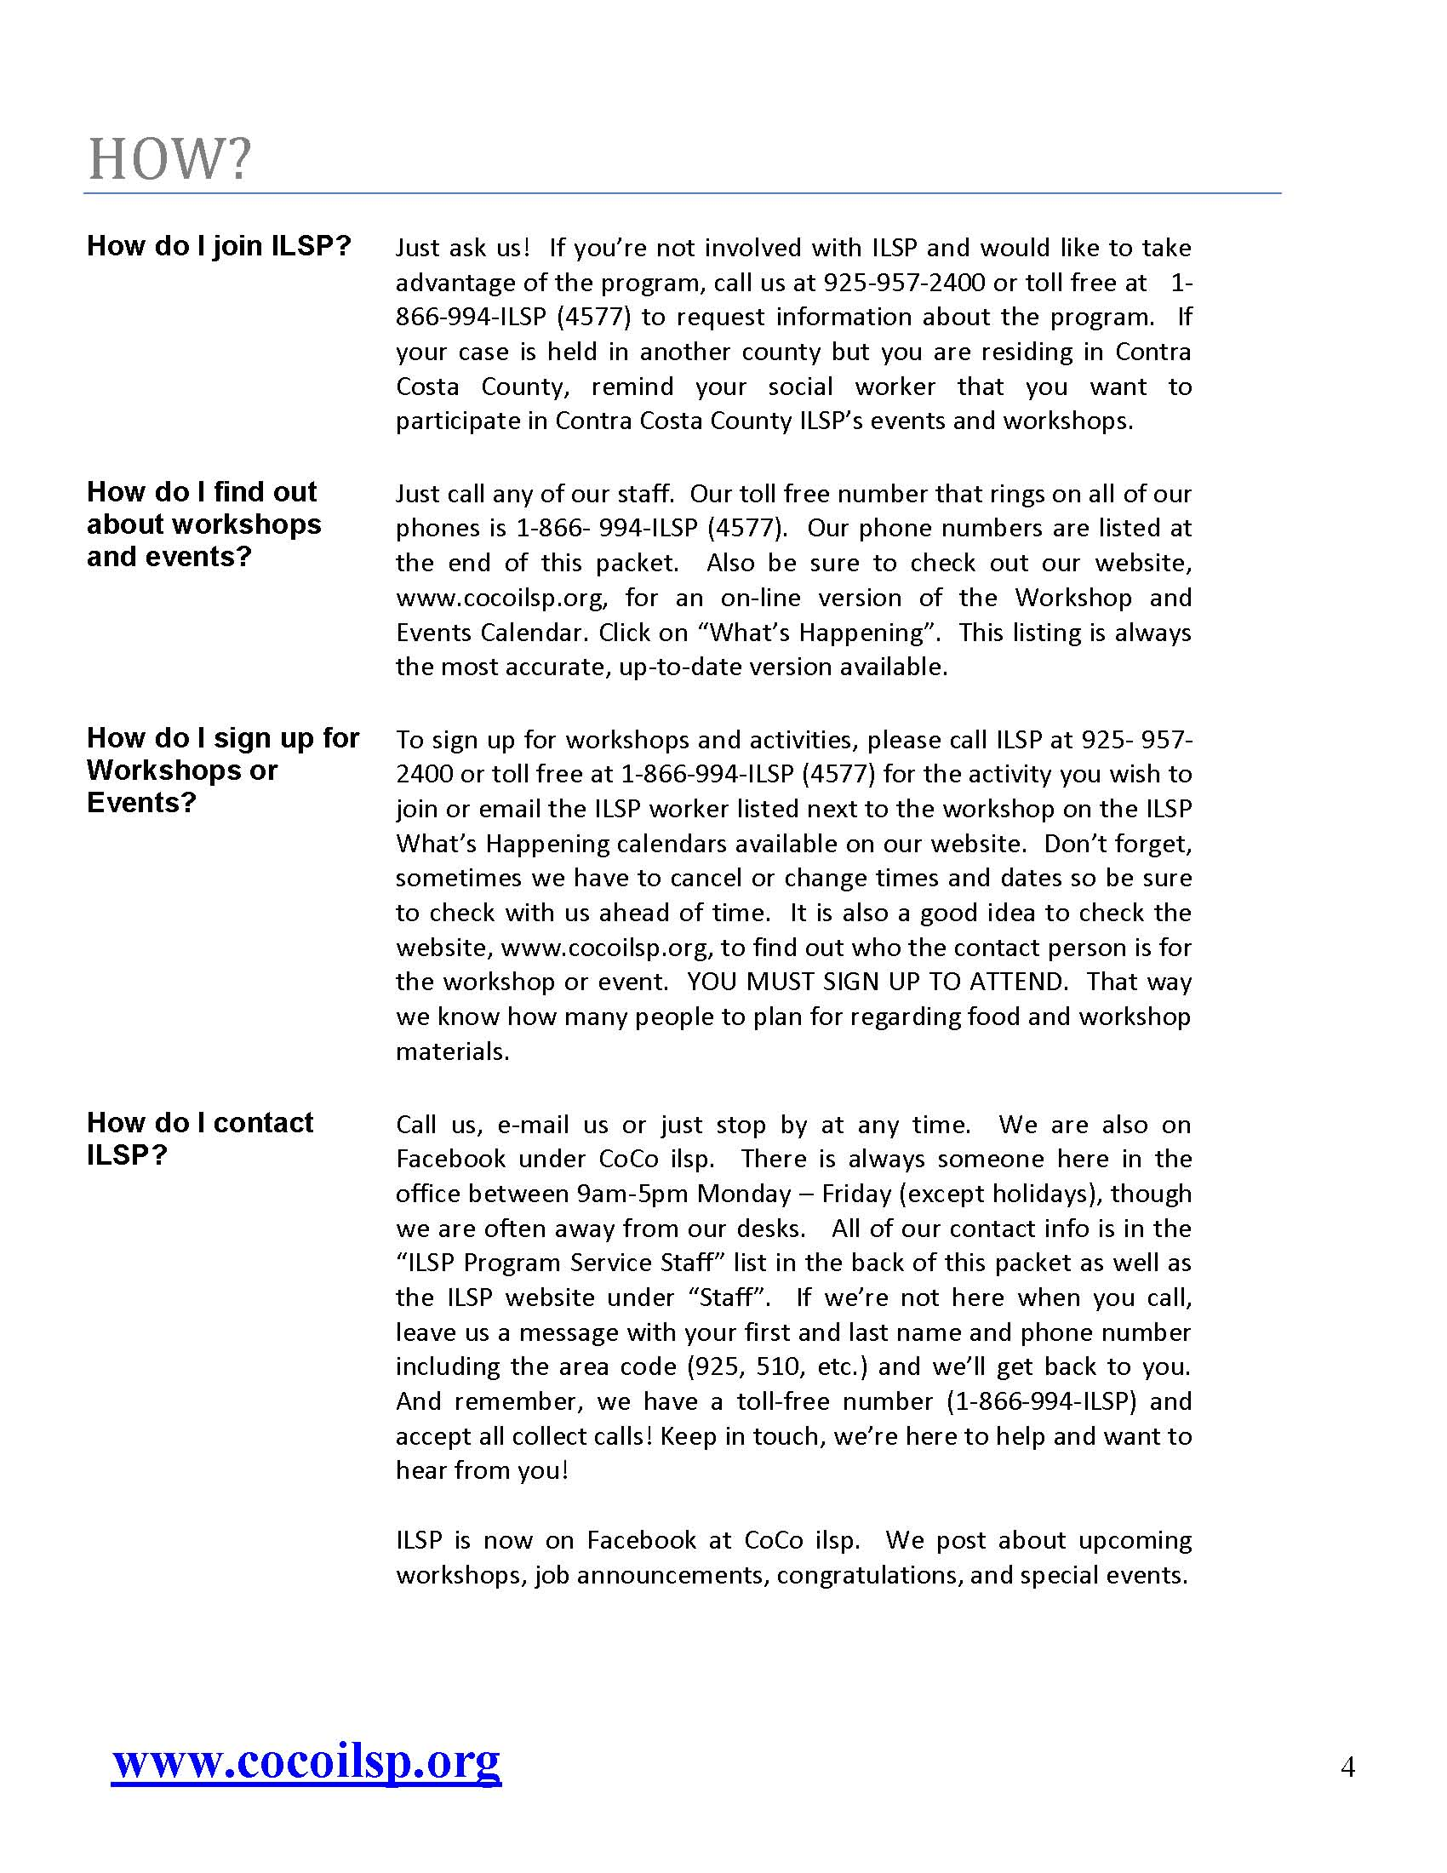Outlook:\\Mailbox - Mary Jane Harris\Outbox

