I. General

The John H. Chafee Foster Care Independence Program (CFCIP) of 1999 established funding for states to establish and continue Independent Living Programs (ILP) that help youth in foster care through transition into adulthood. To measure the effectiveness of services delivered to foster youth, the Administration for Children and Families (ACF) is required to develop a data collection system to track services provided to independent youth beginning with a needs assessment at 15-1/2 and continuing through receipt of ILP After Care services and a survey that tracks youth from age 17 through age 21. The data collection system is called National Youth in Transition Database (NYTD).

The primary goal of NYTD is to measure how effective current services are in improving transition and outcomes for current and former foster care youth.

II. References

CFR Part 1356, dated 02/26/2008
ACL 08-31, dated 07/18/2008
ACL 11-09, dated 01/19/2011
ACL 11-27, dated 04/21/2011
ACIN NO. I-07-10, dated 01/25/2010
DM 31-235, Independent Living Skills Program, Eff. 03-01-92
DM 31-235,Transitional Independent Living Plan Agreement (TILP) for Foster Youth, Eff. 10-16-09

III. Policy

Effective October 1, 2010 California must provide semi-annual reports to the federal agency, Administration for Children and Families (ACF), identifying delivered Independent Living Program (ILP) services for foster care dependents, wards of the court and ILP eligible former foster youth.

There are two requirements or components that must be met in order to comply with the NYTD program.

- Component One collects demographic information and ILP delivered services gathered from CWS/CMS.

- Component Two is the collection of outcome information by conducting a survey of youth in foster care at age 17, again when youth turn 19, and again at age 21.

A. Component One – Delivered Services

Independent Living Program services delivered to eligible youths are collected from the Delivered Services entries in CWS/CMS. Therefore it is important that all ILP services are documented in CWS/CMS accurately and timely.

1. Served Population

Foster youth included in the data collection are youth who are receiving or have received ILP services including the following:

- Foster youth with open court dependency cases;
- Foster youth in Probation cases;
- Guardianship cases for former court dependents where guardianship was established on or after the youth’s age of eight;
- Guardianship cases where the dependency case is continued after the age of 16;
- Reunification cases where the youth is on a trial home visit;
- Interstate Compact on the Placement of Children (ICPC) cases supervised by California, and
- Closed cases (including Kinship Guardianship Assistance Payment (Kin-GAP) and finalized adoptions and aftercare) that receive ILP services.

2. Needs Assessment

Beginning at age 15 ½ needs assessment information is gathered based on entries in CWS/CMS via the Transitional Independent Living Plan (TILP).

3. Delivered Services

The following ILP service information must be entered into CWS/CMS to comply with NYTD data collection:

- ILP Core Services

The following ILP core services appear in CWS/CMS as a drop down menu in the Delivered Services page in the Case Notebook. These services must be entered into CWS/CMS when services are provided.

Core Services
ILP-Needs Assessment | ILP-Home Management
ILP-Education | ILP-Housing Options/Locations/THPP
ILP-Education/Post-Secondary | ILP-Health Care
ILP-Career/Job Guidance | ILP-Interpersonal/Social Skills
ILP-Employment/Vocational Training | ILP-Parenting Skill
ILP-Money Management | ILP-Mentoring
ILP-Consumer Skills | ILP-Transitional Housing
ILP-Time Management

- Examples of services are listed below. Services may include but are not limited to the following:

- Opening a savings account
- Money management
- Nutrition
- Grocery shopping

- Menu planning and preparation
- Home management
- Personal hygiene
- Fitness and health care

- Reportable delivered services include those offered by someone other than county workers. (For example, caregivers)

d. Independent Living Program services delivered to out-of-county youth, ICPC youth (supervised by CA) or former foster youth must also be entered into CWS/CMS.

e. All ILP eligible youth must be offered ILP services. Provided ILP services must be entered into CWS/CMS.

f. Independent Living Services staff with closed case /referral privilege will be able to update/create Contacts, Education, Collateral and Service Provider Notebooks. (Providing the case was in county of last assignment and had access to case.)

In closed Adoption cases, users with Adoptions privilege and a primary assignment to the case will be able to update/create Contact and Educations Notebooks.

B. Component Two – Youth Surveys

Component Two consists of a survey given to youth on their 17th birthday, again when they turn 19 and again at age 21. The Center for Public Policy Research at the University of California, Davis (UC Davis) was chosen to conduct these surveys. There are two objectives for Component Two: 1) to obtain survey responses within 45 days of the surveyed birthdays and 2) to gather enough surveys to represent youth population. (See Attachment I, Youth Survey) Youth participating in the survey can complete it in one of three ways:

1) Online at: www.calnytd.org, click on “Take the Survey”

2) By calling toll free at 1-877-426-6983 and completing the survey by phone.

3) By completing a hard copy of the survey sent to them by UC Davis and mailing to the address below or by giving it to their social worker. The social worker may also provide the survey to youth:

Center for Public Policy Research
1632 Da Vinci Court
Davis, CA 95618

1. Youth Voice in Survey

Encouraging youth to participate in the survey is vital to the success of this program. Active encouragement from social workers and foster care providers is key to the success of this program.

2. Baseline population

a. On a monthly basis UC Davis will receive a list from California Department of Social Services (CDSS) of foster care youth who are reaching their 17th birthdays. This list will include the youth’s last know addresses and phone numbers.

b. The baseline survey will consist of foster youth, whose 17th birthdays fall between October 1 and September 30. These surveys should be completed no later than 45 days of the youth’s birthday.

c. Youth who complete the baseline survey will be surveyed again when they reach the ages of 19 and 21.

3. Outcome data that will be collected by the survey includes the following:

- Financial self-sufficiency | - Positive adult connections
- Experience with homelessness | - High-risk behavior
- Educational attainment | - Access to health insurance

4. Survey Demographics

Success of this survey will be reliant on the accuracy of the demographic data entered into CWS/CMS. It is imperative that the following demographic data is correct.

Demographic | CWS/CMS notebook location
Date of birth | Client notebook - ID page - Client information
*Race/ethnicity | Client notebook - ID page - Race/Ethnicity.  See Attachment II for NYTD-reportable data Race categories
Gender | Client notebook - ID page - Client information
Education | Education notebook – Grade Level information page – Grade field- Start Date field  Education should be updated as necessary.

IV. NYTD Quality Assurance Report

A. The quarterly NYTD Quality Assurance Report will be issued to assist counties in correcting errors before the NYTD report is extracted.

1. Data will be reviewed on an ongoing basis as new youth age to 16, or as new errors are identified.

2. Highlighted errors consist of missing, inconsistent or incomplete delivered service information and demographic data.

3. California Department of Social Services (CDSS) will send the Quality Assurance report to Health and Human Services Research Evaluation Manager and the ILP Coordinator.

B. The quarterly NYTD Quality Assurance Report will be sent to the CFS Bureau Director and disseminated by the Division Manager to the supervisor of the assigned social worker. The assigned social worker will be responsible for correcting any errors listed. The social worker will inform their supervisor after all corrections are completed.

V. Sanctions for Non-Compliance

Accurate and timely information is critical to the success of this program. States are required to get at least 80% of youth in foster care to participate, 60% participation of youth who have left care and a 90% data accuracy rate. States unable to provide accurate reports and comply with youth participation rate standards, may risk the loss of up to 1% to 5% of their annual Chafee ILP funding.

VI. Procedures

A. Social Worker will:

1. Confirm and maintain current contact information for all 17 year olds on their caseload and promptly update CWS/CMS when new information becomes available including mailing addresses, phone numbers and any other information that will assist contacting participating youth.

2. Enter and/or update each contact, ILP core services/other services and visits in CWS/CMS in a timely manner, or complete form CWS 17, CWS/CMS Contact/Associated Services/ Associated Visits Worksheet and narrative for each contact, service and visit and submit to Clerical Staff for entry into CWS/CMS.

3. While conducting monthly face-to-face visits with youth beginning at age 17 years old:

a) Provide information regarding the NYTD program. Youth must be offered the opportunity to take the survey and the response must be no later than 45 days after their 17th birthday. Explain the importance of the survey to youth and encourage them to participate.

b) Inform youth of the three ways to complete the survey.

Social workers and caregivers may assist youth in completing the survey without coaching or editing responses. It is important the survey captures the youth’s voice.

4. Notify youth that respond, they will be asked to complete subsequent surveys at ages 19 and 21.

5. If youth decline to complete the survey, social workers must:

a. Complete the e-mail template (see Attachment III)

E-mail to cal.nytd@gmail.com and NYTD@dss.cs.gov cc social work supervisor and ILP Coordinator the below information.

b. The following information should be included in the e-mail:

- A 19 digit case ID number (Must be used in order to maintain confidentiality.)
- Date youth decline to complete the survey.
- Statement that the youth declined to complete the survey.
- The youth’s response.

Example:
Subject: NYTD Decline of Survey

ID Number: 1111-2222-3333-4444444

Date: 08-23-2011 (Date youth declined to complete survey)

Statement: Youth declined = Youth was contacted and declared that he or she is not interested in participating

Youth’s response: I don’t have anything to say and I don’t want to complete the survey.

c. An Outlook template “NYTD Youth Response” will be added to the Outlook Organizational Forms Library to assist in sending the above e-mail. (Attachment III) See instructions below:

      - Open Outlook
      - Go to the Tools menu
        - Forms
        - Choose Form
      - Under Organizational Forms Library (the default option) choose the NYTD Template

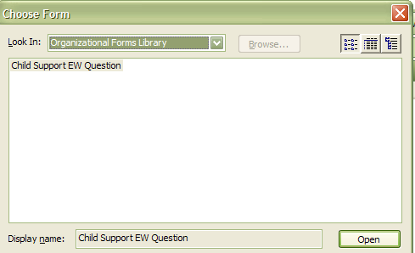
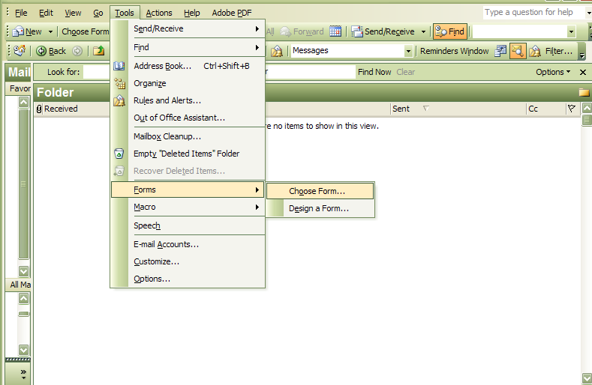
NYTD Youth Response
NYTD Youth Response

1
2
3

4

6. When meeting with caregivers of youth aged 15-1/2 and older:

a) Explain the NYTD program and the importance of accurate and timely reporting of service delivery information. Discuss with caregivers the impact the survey will have on the delivery and content of ILP services.

b) Inform caregivers that they should encourage youth to participate in the survey and help youth respond within the allotted time period.

c) Ask caregivers what ILP services they or others have provided to the youth. These services must be entered and continually updated in CWS/CMS.

d) Have caregiver complete/update the CFS ILP3, Independent Living Program (ILP) Delivered In-Care and Aftercare Services Report for Youth in County from another County/State form. (See Attachment IV)

e) Enter new information in CWS/CMS as necessary.

f) Make necessary corrections upon receipt of the NYTD Quality Assurance Report for respective cases and notify supervisor when corrections are completed.

B. Social Work Supervisor will:

1. On a monthly basis, retrieve a report of youth who are approaching the NYTD survey deadline from Safe Measures. (Report is entitled, “Time to NYTD Survey”.) This report shows the time to the due date for the NYTD survey for all youth in an open placement episode.

a. Review case list for NYTD time frames and inform assigned social worker of NYTD youth close to the survey deadline.

2. Ensure social workers meet with youth and caregiver to discuss NYTD and its importance on the service outcomes for foster youth.

3. Make sure ILP data and services are entered timely and correctly into CWS/CMS.

4. Ensure all Quality Assurance report errors are corrected by the social worker.

C. Independent Living Skills Program Specialist will:

Meet with youth and caregivers to discuss NYTD, enters ILP data and delivered services for all youth timely and correctly in CWS/CMS.

D. Independent Living Skills Program Coordinator will:

1. Ensure Independent Living Skills Program Specialists meet with youth and caregivers to discuss NYTD, enter ILP data and services timely and correctly into CWS/CMS.

2. Having closed cases access, he or his designee will record delivered ILP services for former foster youth.

E. Clerical Staff will:

Enter contact, associated services, associated visits, and narratives into CWS/CMS based on the social worker and/or Independent Living Skills Program Specialist completed form CWS 17.

F. Clerical Supervisors will:

Ensure Clerical Staff enter contact, associated services, associated visits, and narratives into CWS/CMS based on the Social Casework Specialists’ completed form CWS 17.

VII. Attachments

I. Youth Survey
II. NYTD-Reportable Race Categories
III. Outlook template for youth who decline to take NYTD survey
IV. Children and Family Services ILP3, Independent Living Program (ILP) Delivered In-Care and Aftercare Services Report for Youth in County from another County/State

VIII. Contact Person: First-line Supervisors and above may contact the Permanency Analyst with questions concerning this Department Manual Section.

Youth Survey
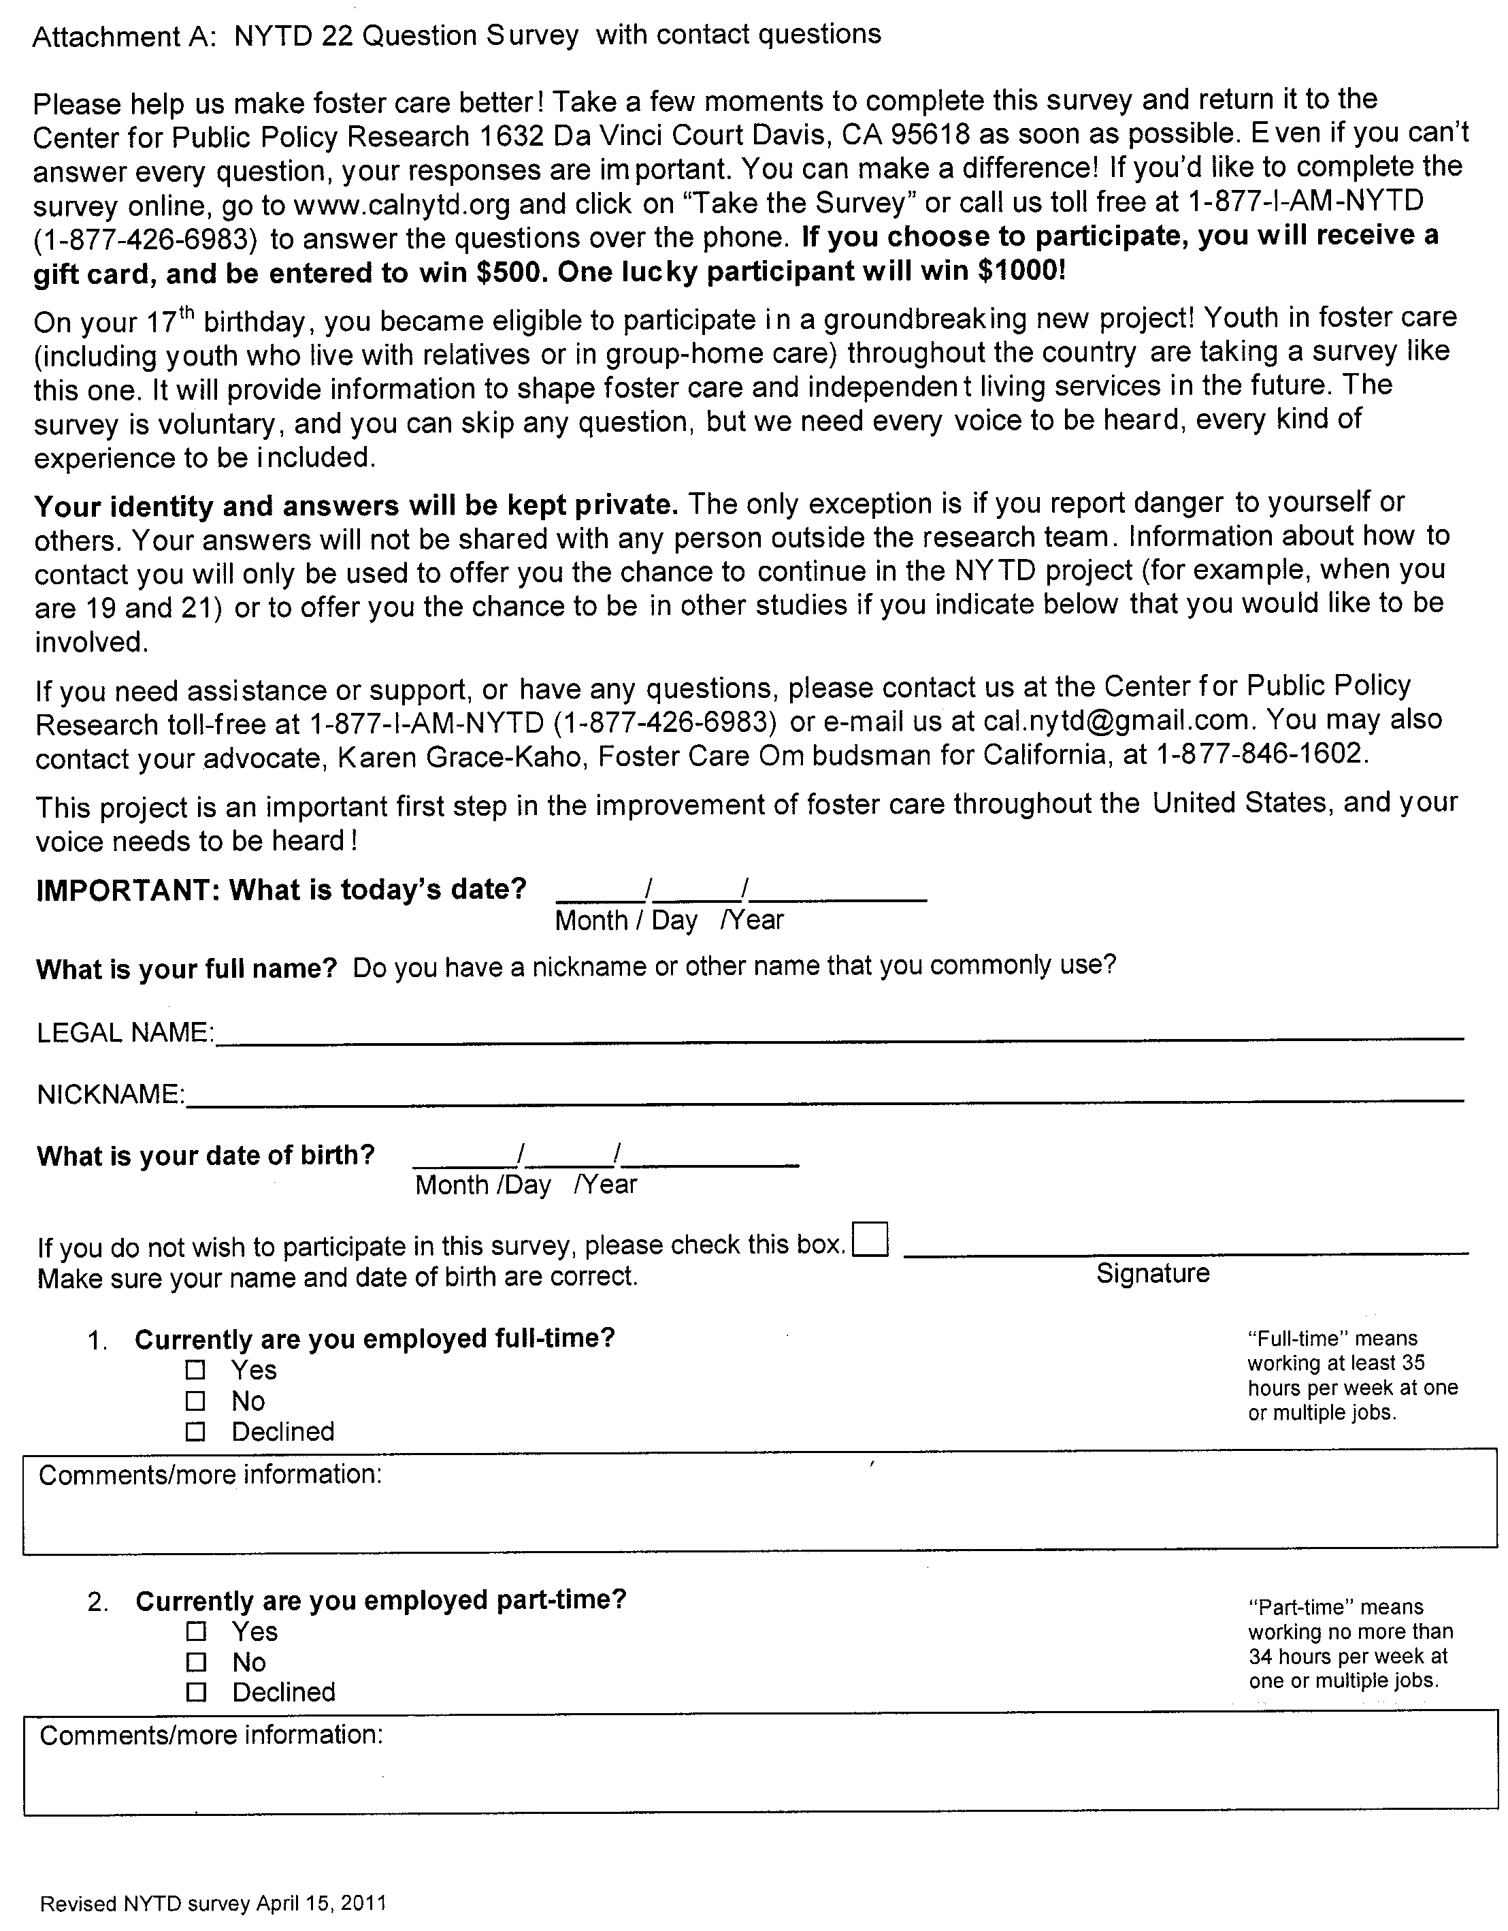
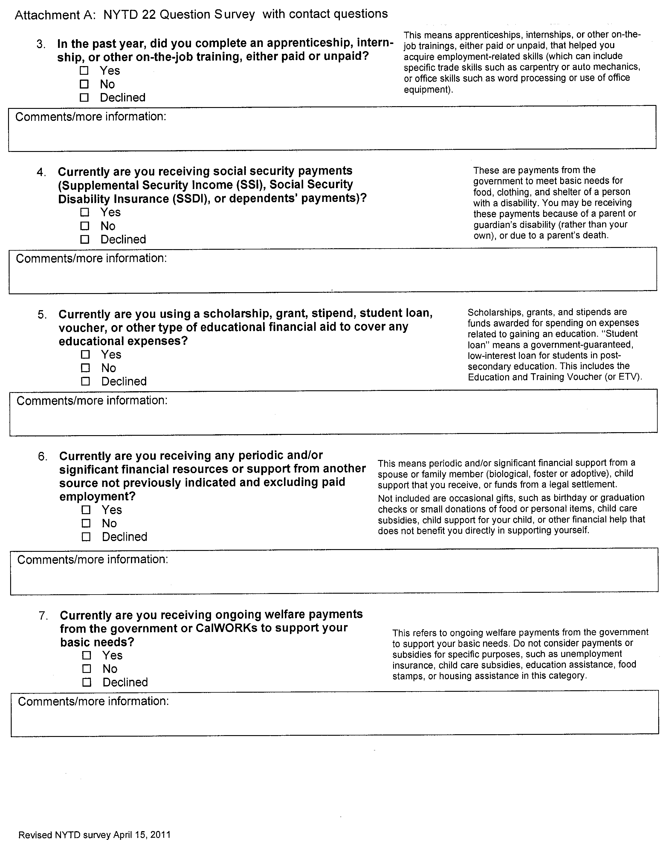
Youth Survey
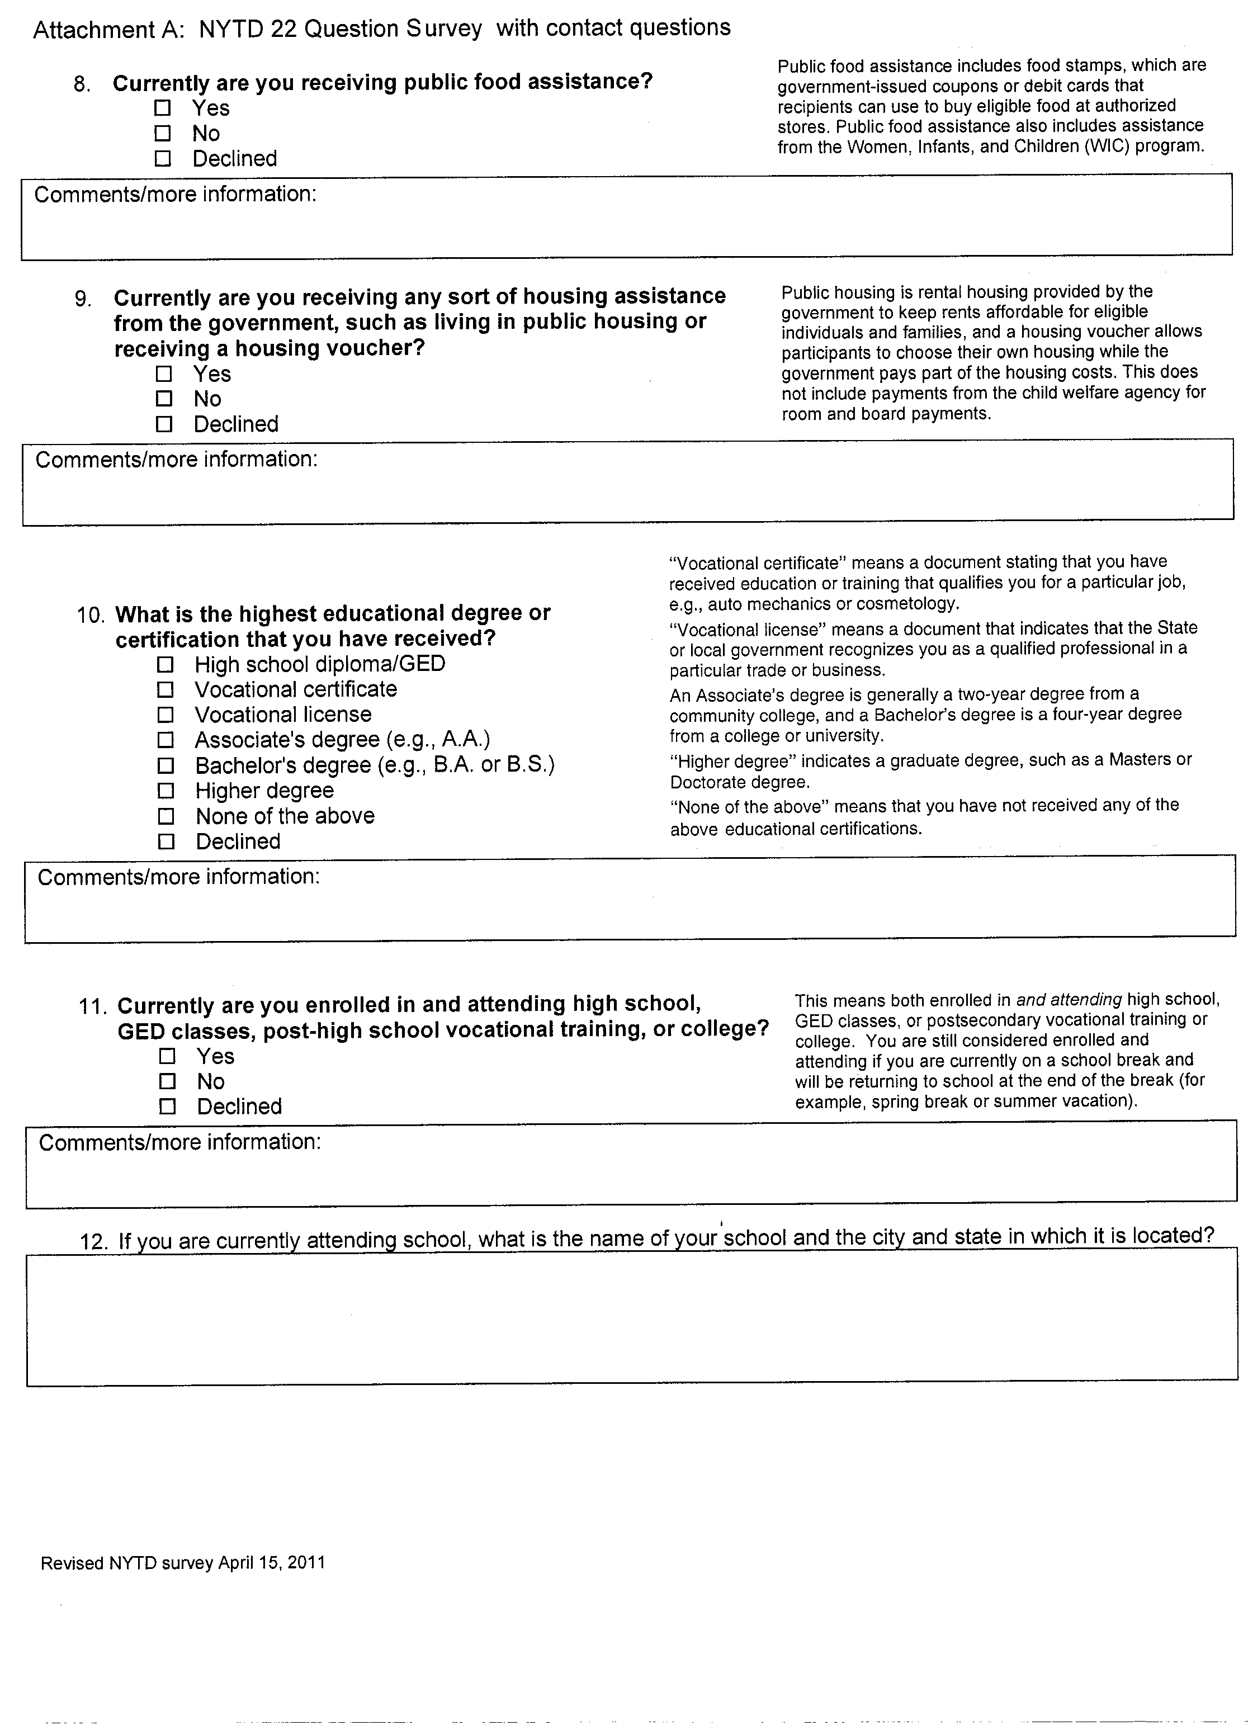
Youth Survey
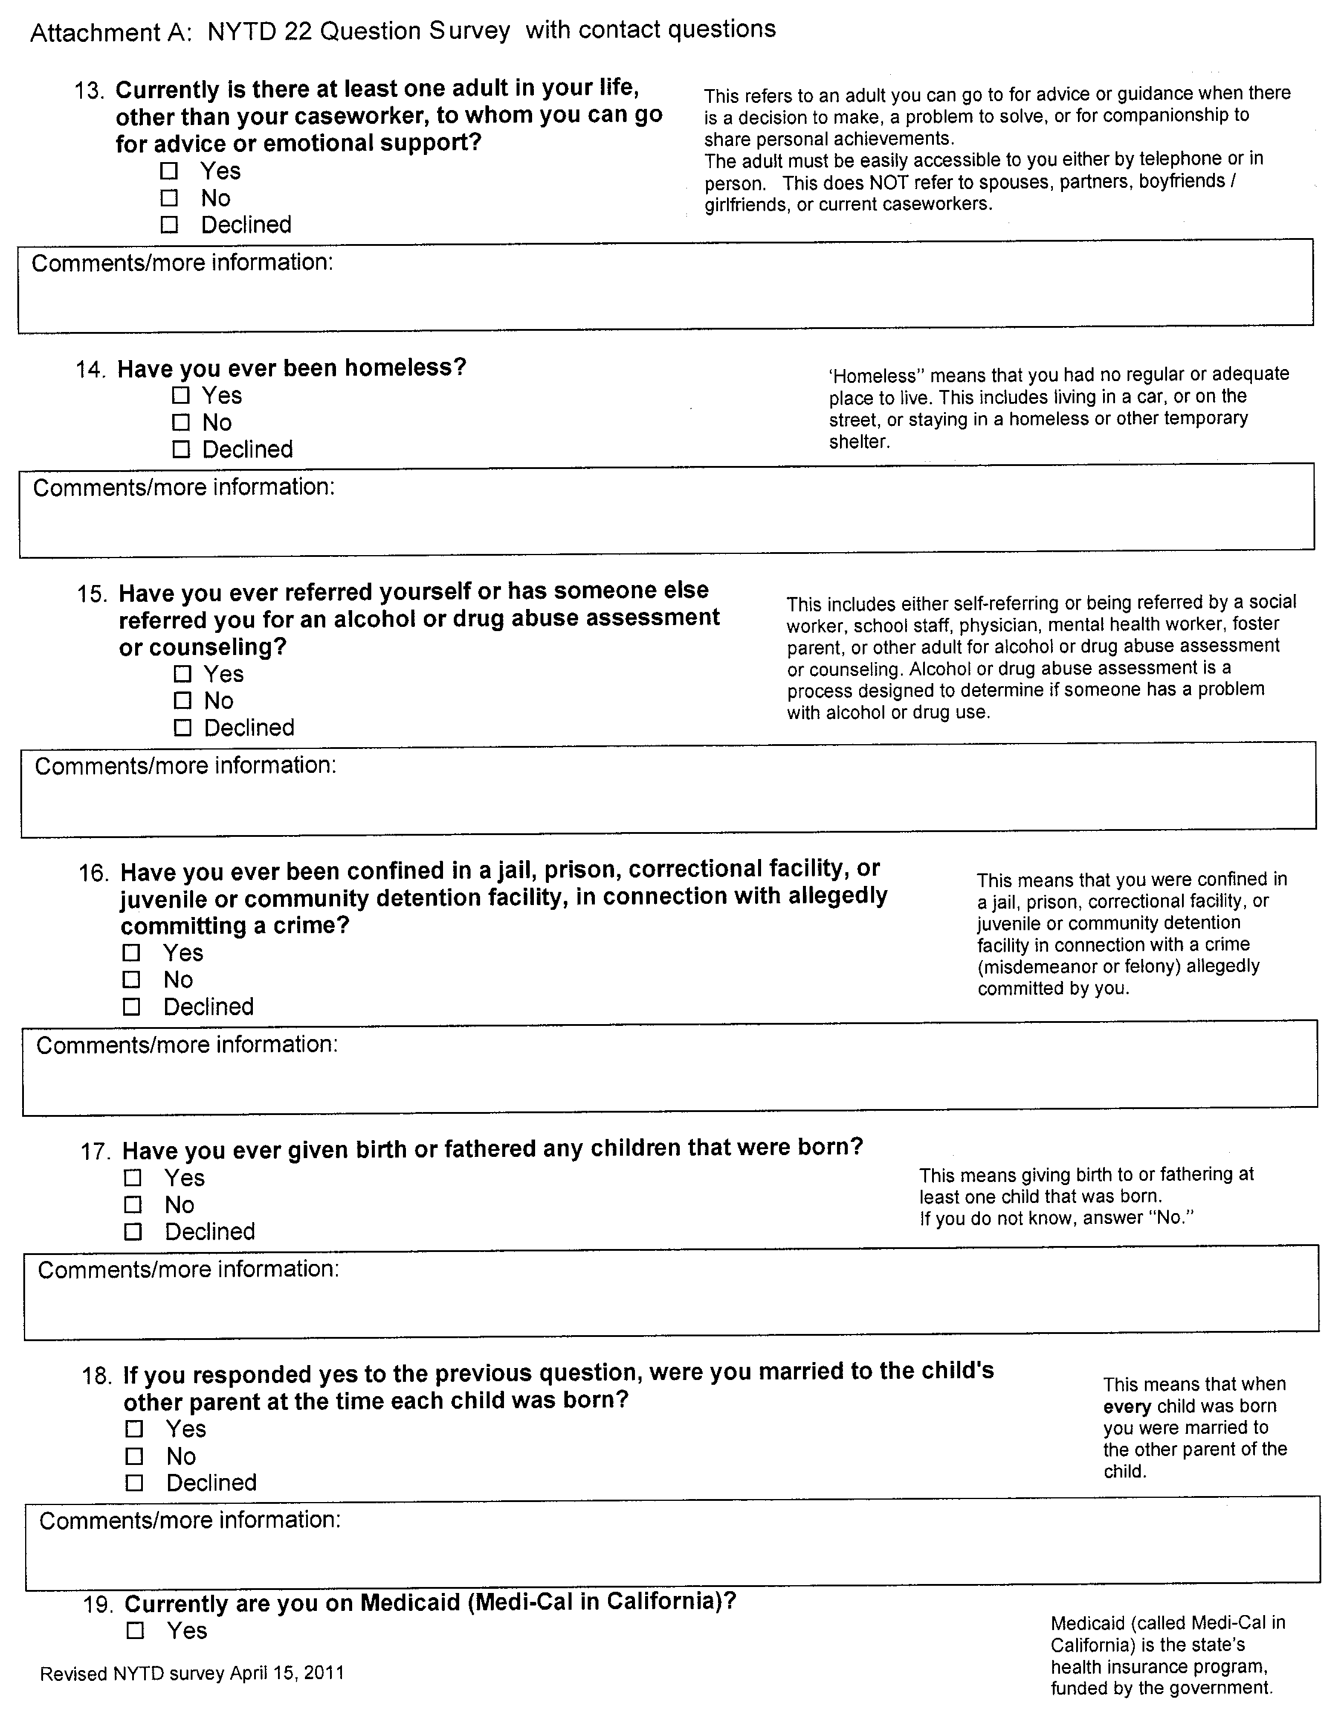
Youth Survey
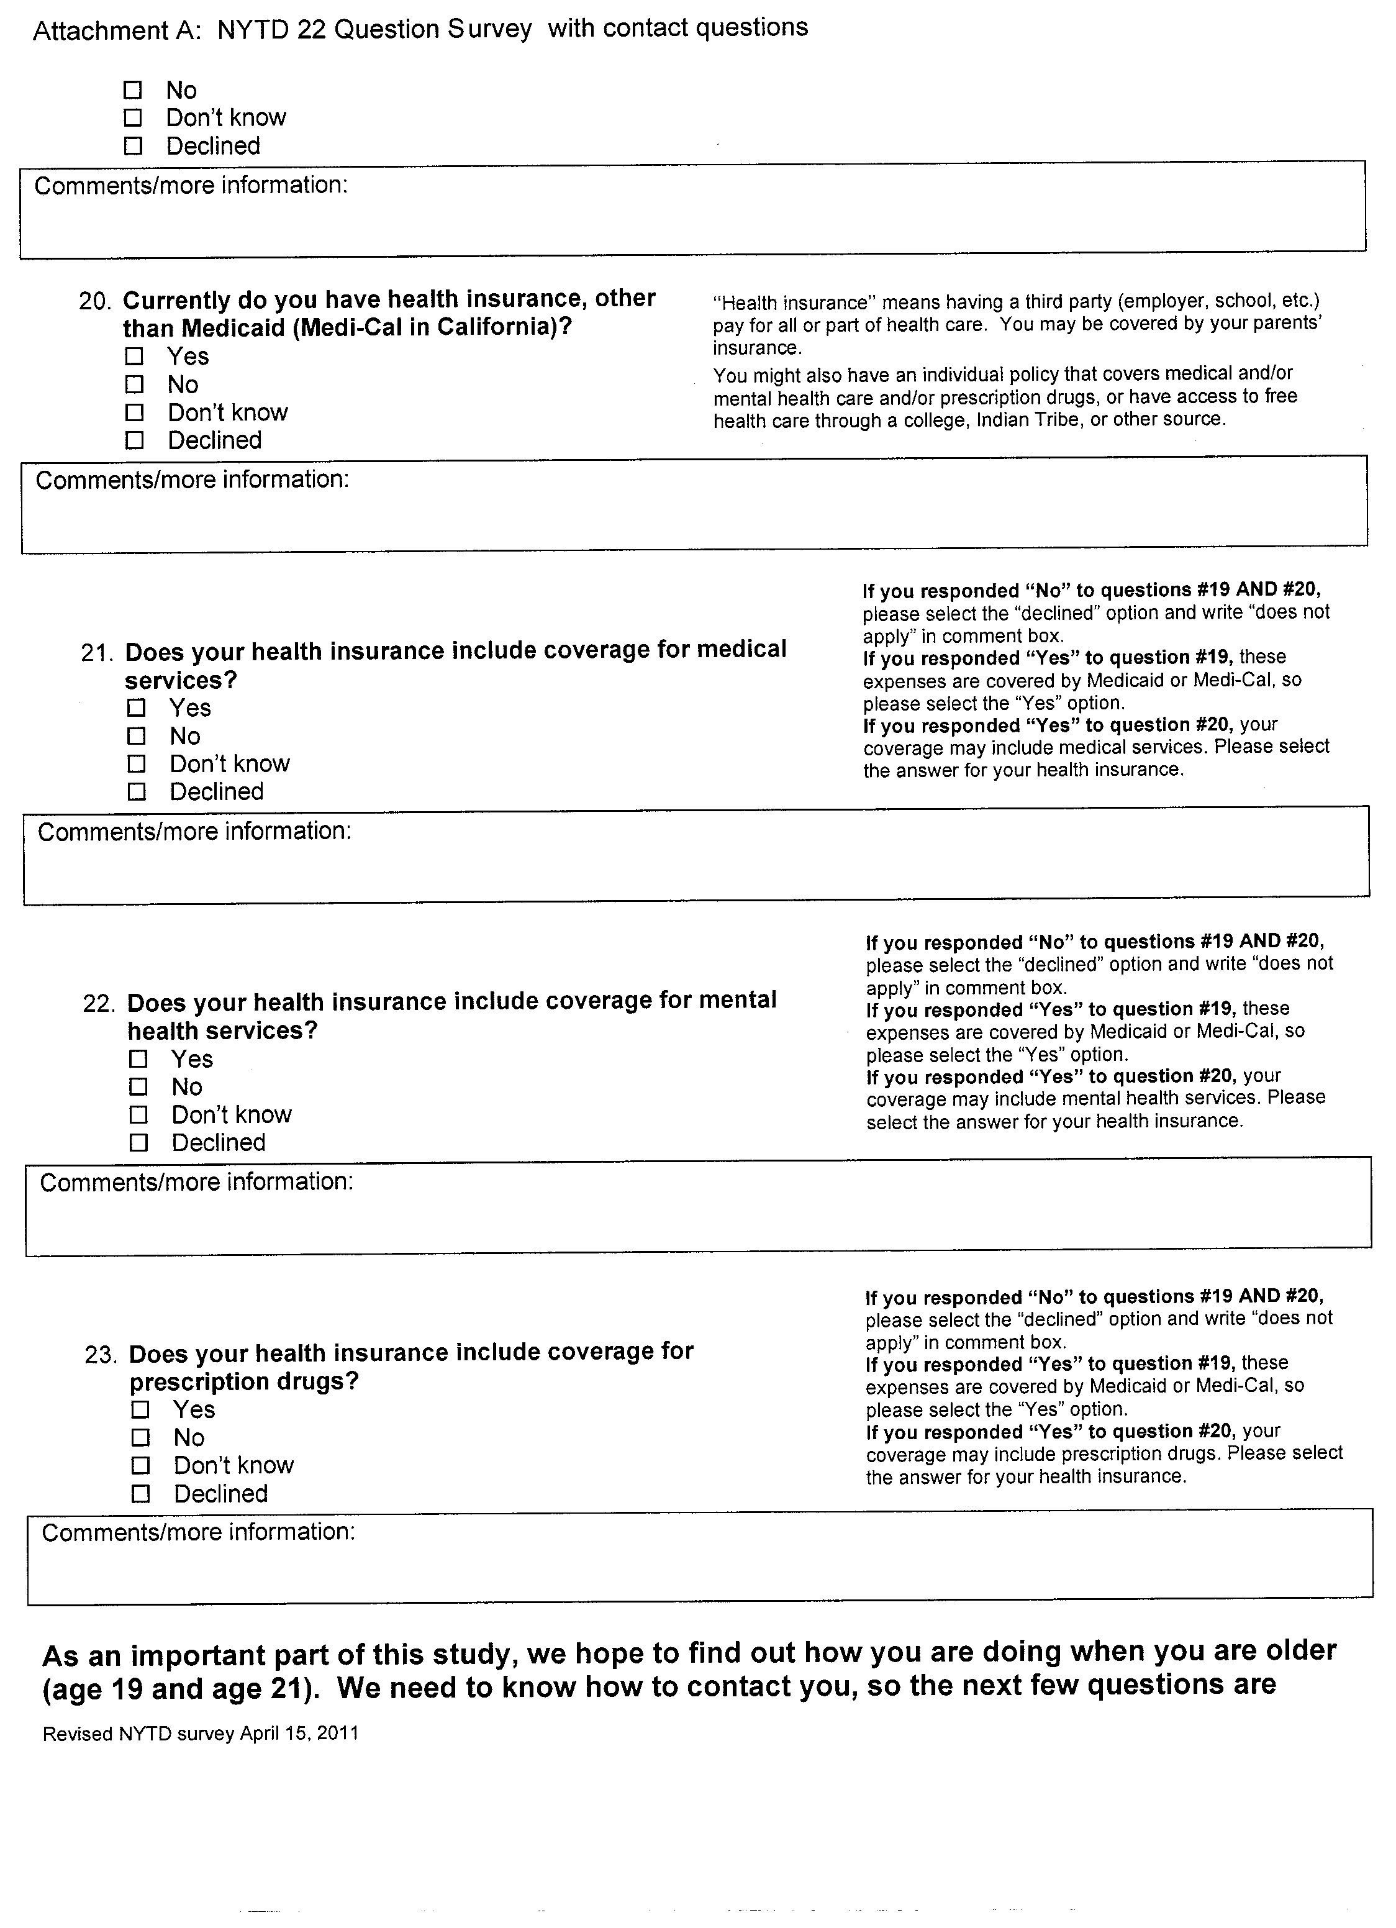
Youth Survey
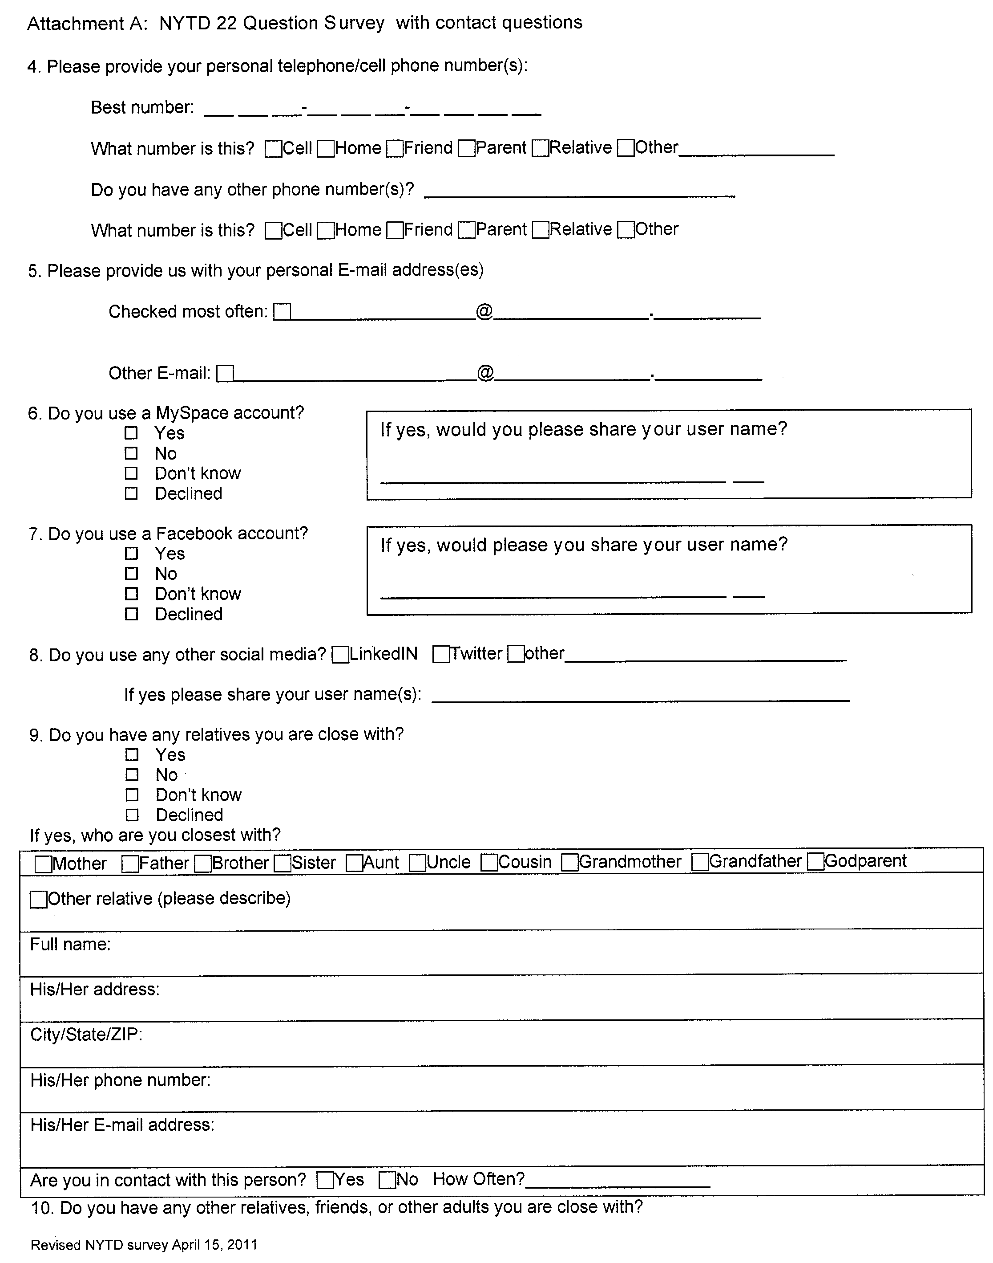
Youth Survey
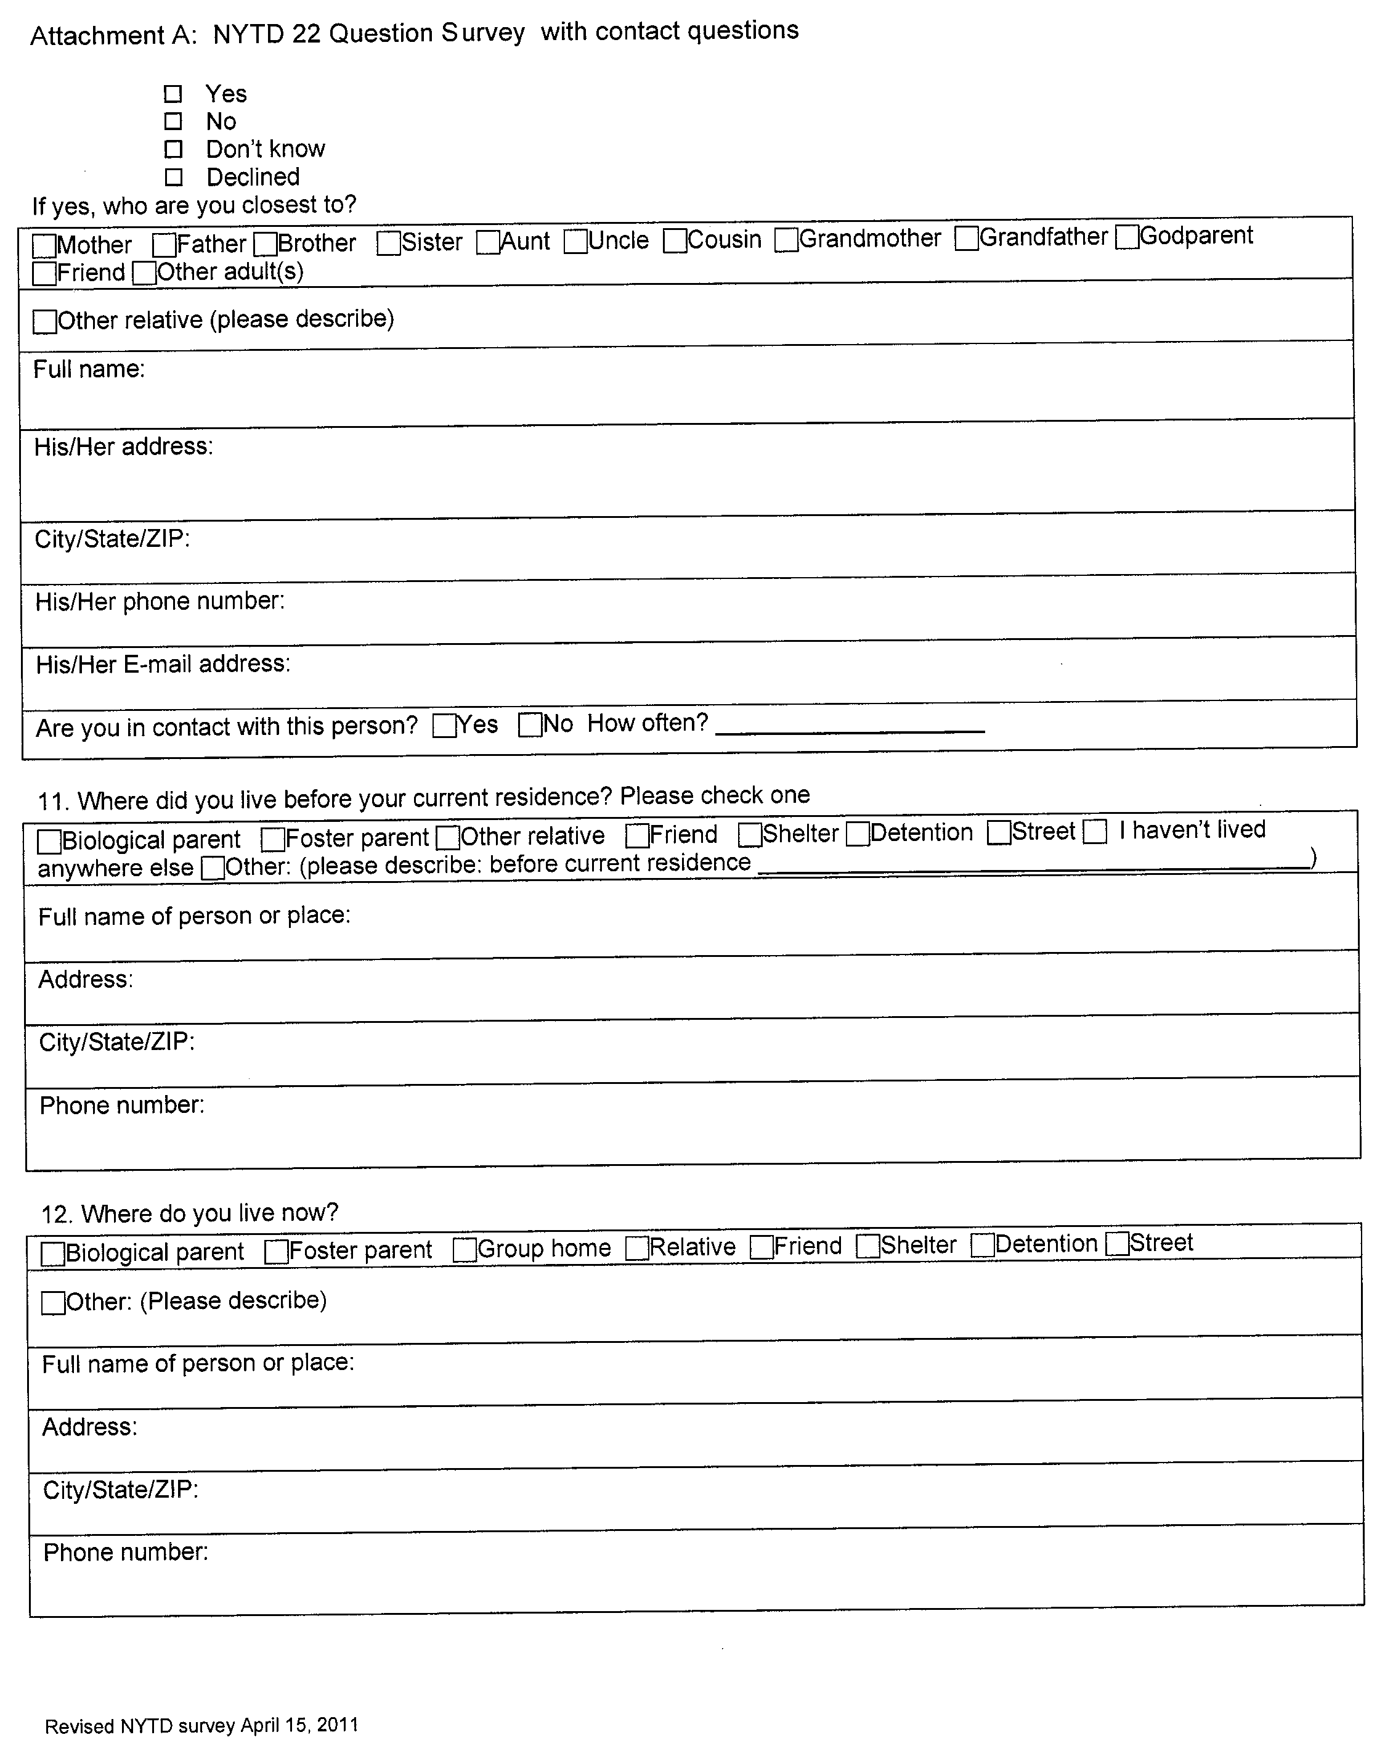
Youth Survey
Youth Survey

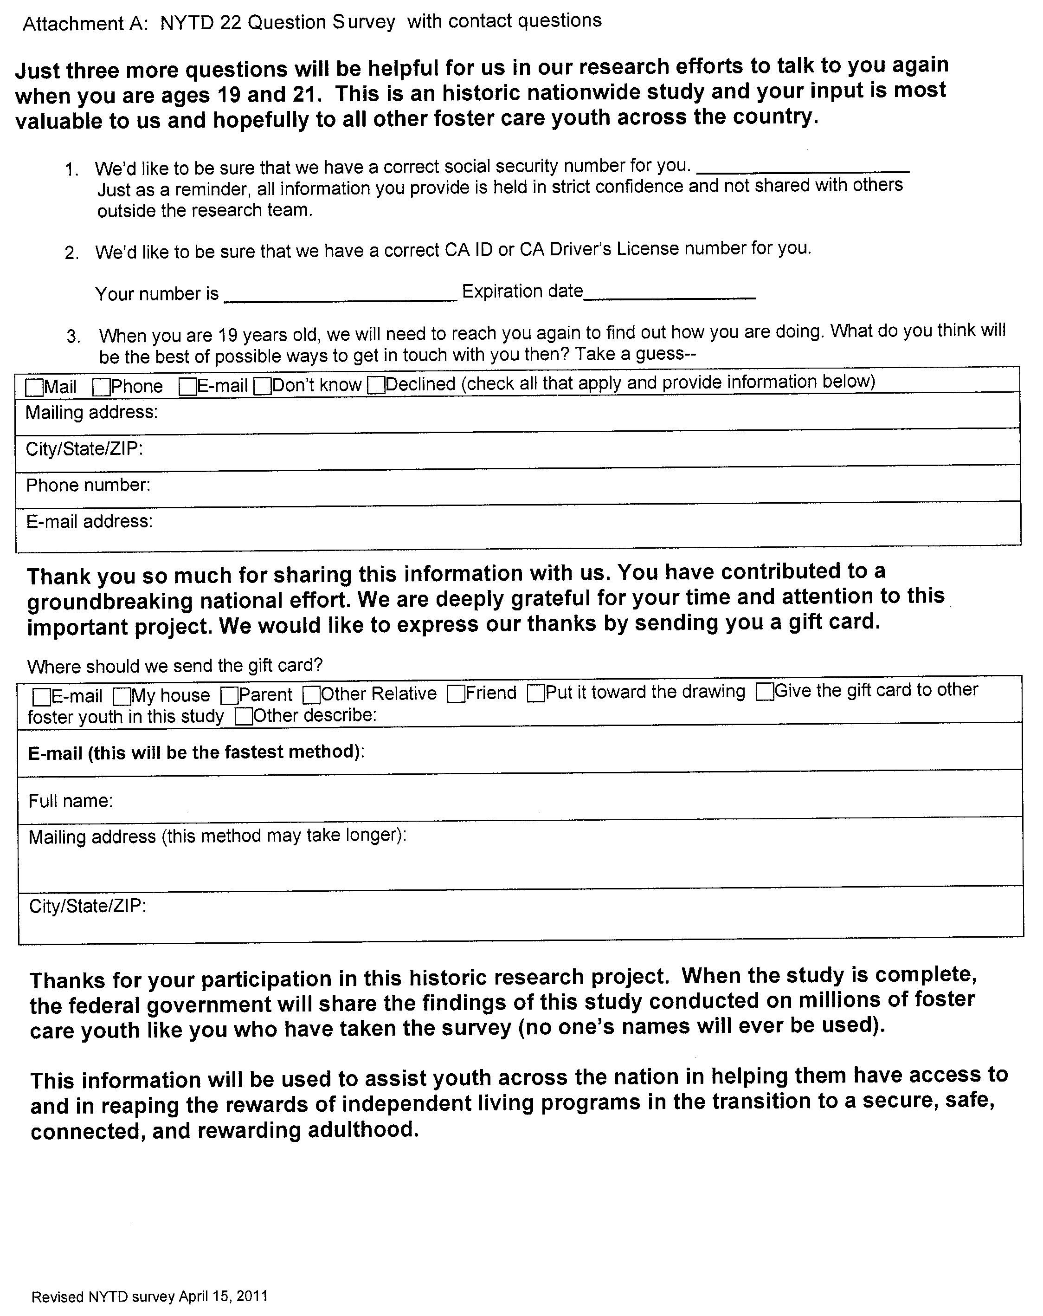

NYTD-Reportable Race Categories

NYTD Categories | CWS/CMS Primary Ethnicity
American Indian or Alaskan Native | Alaskan Native | American Indian
Asian | Asian Indian | Korean
 | Cambodian | Laotian
 | Chinese | Hmong
 | Filipino | Guamanian
 | Japanese | Vietnamese
 | Other Asian
Black or African | Black | Ethiopian
Native Hawaiian or | Hawaiian | Samoan
Other Pacific Islander | Polynesian | Other Pacific Islander
White | White
 | White - Armenian
 | White – Central American
 | White - European
 | White – Middle Eastern
 | White - Romanian
Unknown | Unable to Determine
Declined | Declines to State
NOTES: Two fields in CWS/CMS (Primary Ethnicity and Hispanic or Latino Origin) are combined to determine race and ethnicity values for NYTD reporting. Enter necessary information in these fields.

PLEASE NOTE: Only the youth may make the choice and select a race or a Hispanic ethnicity.
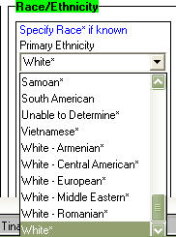
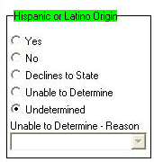

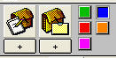

Outlook Template for Youth who Decline to Take the NYTD Survey

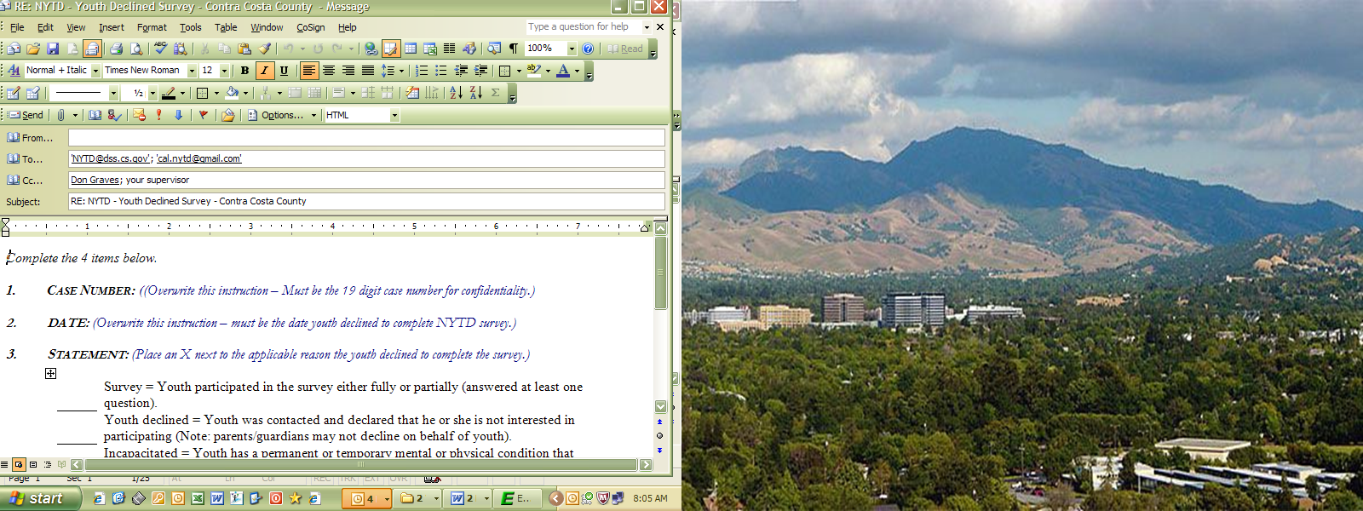

Complete the 4 items below.

1. Case Number: (Overwrite this instruction – Must be the 19 digit case number for confidentiality.)

2. DATE: (Overwrite this instruction – must be the date youth declined to complete NYTD survey.)

3. Statement: (Place an X next to the applicable reason the youth declined to complete the survey.)

Survey = Youth participated in the survey either fully or partially (answered at least one question).
Youth declined = Youth was contacted and declared that he or she is not interested in participating (Note: parents/guardians may not decline on behalf of youth).
Incapacitated = Youth has a permanent or temporary mental or physical condition that prevents him or her from participating in the survey.
Incarcerated = Youth is unable to participate in the survey because of his or her incarceration.
Runaway/missing = Youth is known to have run away or be missing from his or her foster care placement.
Deceased = Youth died prior to participation in the survey

4. Youth’s Response: (Overwrite this instruction – Use youth’s own words when he/she declined to complete survey.)

Thank you,

Contra Costa County
Employment & Human Services Department
Children and Family Services Bureau

